Section 1: Getting started

Section 2: Data types and Variables

Section 3: Operators and Control flow

Section 4: Arrays slices and maps

Section 5: Using functions

Section 6: Pointers

Section 7: Struct method and interfaces

Section 1: Getting started

**Introduction**

**Golang :** is open programming language created by google

**Note :**

Docker and k8s written in go

**Golang** : created by engineers at google

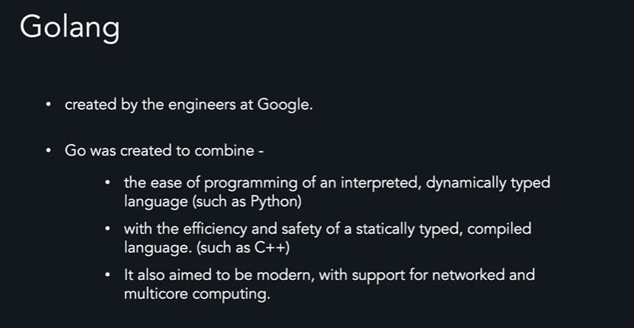

**Golang** is compiled programming language which means the source code we write is translated into

Language that computer can understand

**Download go :**

<https://go.dev/doc/install>

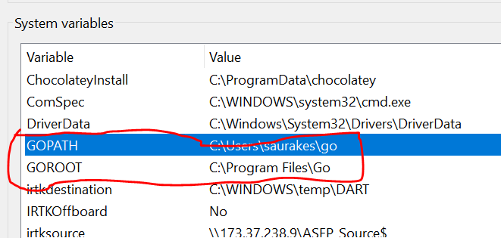

**First go program**

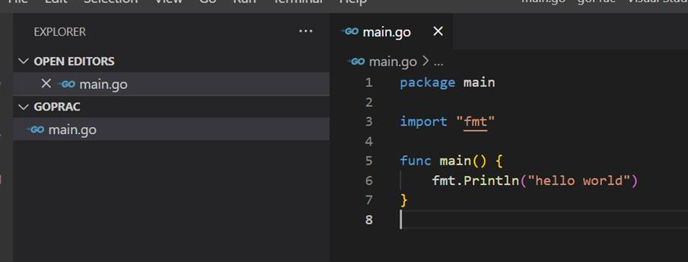

Package : reusing code

**Package main**

Every go program must start with package declaration

We are developing executable program for making the package as executable program

**Import "fmt"**

We use import keyword to include code from other packages.

Fmt package is short form of format. And we importing it because we need the functionality provided by it.

Package name during import is surrounded by double code

Main function is entry point of executable program

There is no need to call main function explicitly

Every executable program must contain single main function

Section 2: Data types and Variables

**Data type**

Why data type needed :

Categorize a set of related values

Describe the operation that can be done on them

Define the way data is stored ( memory allocation)

Ex : integer need 4 or 8 byte

**Static vs dynamic typed language**

**Static typed:**

Compiler throws an error when types are used incorrectly

Example

c++ , java

**Dynamic typed**

Compiler does not enforce the data type system

Example

Python, javascript

**Static types advantages**

* Better performance
* Bugs can be often caught by a compiler
* Better data integrity

**Dynamic types advantages**

* Faster to write codes
* Generally less rigid
* Shorter learning curve

**Golang :**

* Golang has a concept of types that is either explicitly declared by a programmer or is inferred by the compiler
* It is a fast ,statically typed,compiled language that feels like a dynamically typed, interpreted language

name:="abc" ( short variable declaration , compiler implicitly assigned string data type to name variable)

**Kind of data types**

**Numbers split into two types :**

**Integer** represented by **int**

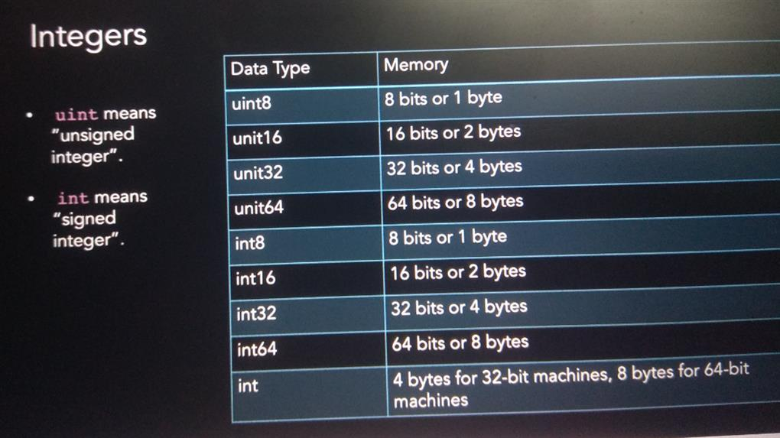

**Unit** : means unsigned integer which means they will contain only positive number including zero

**Int** : means signed integer they will contain both positive as well as negative

**Float**

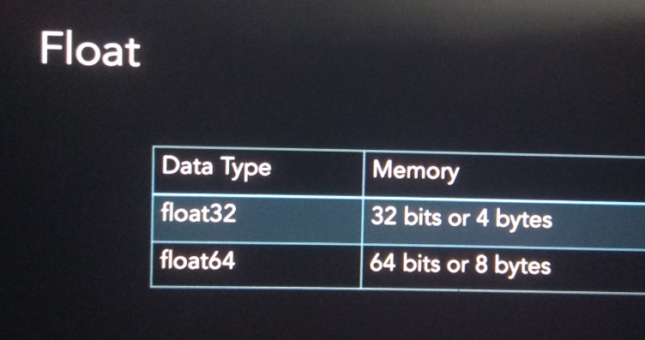

**String** represented by **string** (memory 16 bytes)

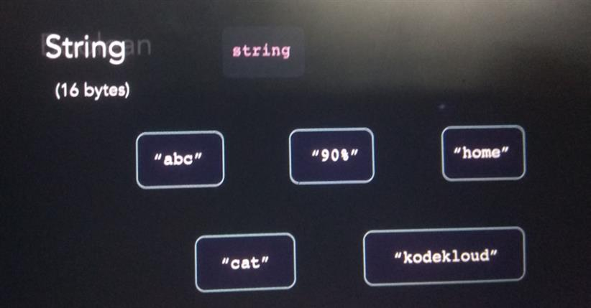

**Boolean** represented by bool ( memory 1 byte)

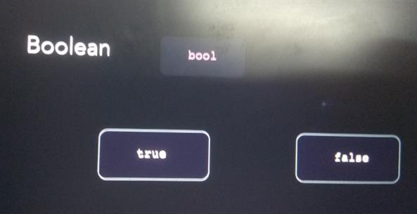

**Variable ,syntax and declaration**

**Variable :**

It is simply reference to value

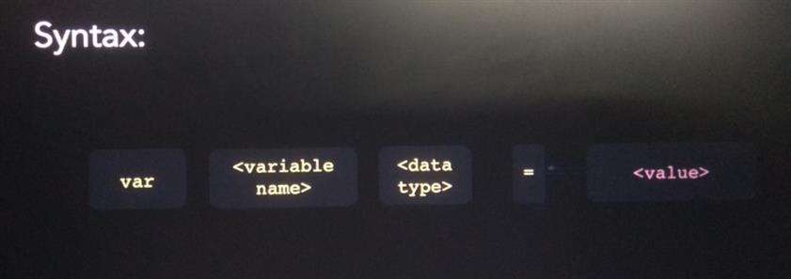

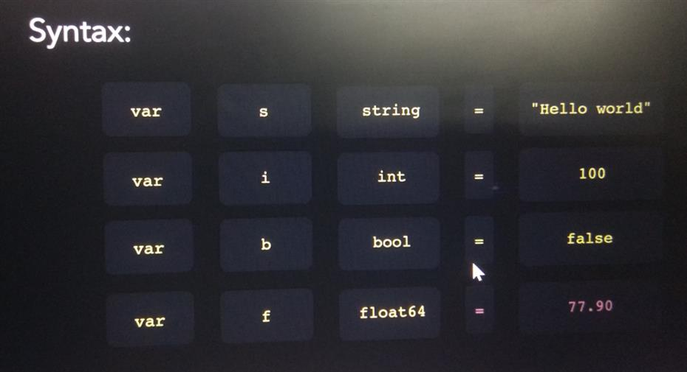

**Printing variables**

**Newline**

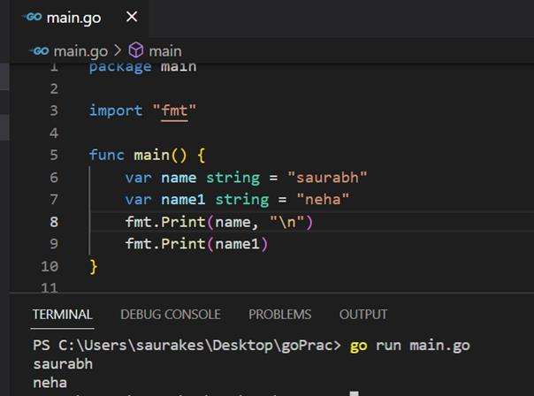

**Println**

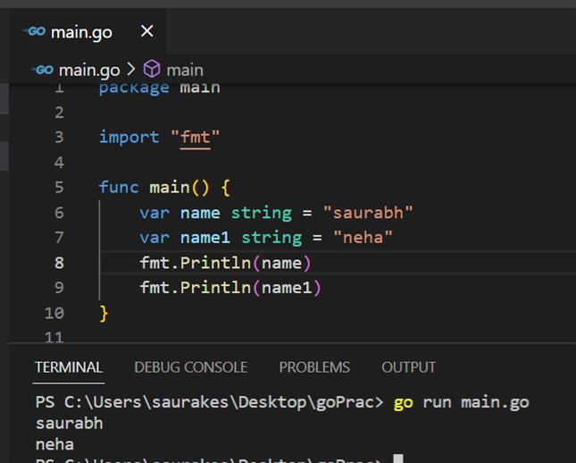

**Printf :** format specifier

**Format specifier** :

tell golang how to format different types of data types

format specifier always preceded by % sign

**%v** : format the value in default format

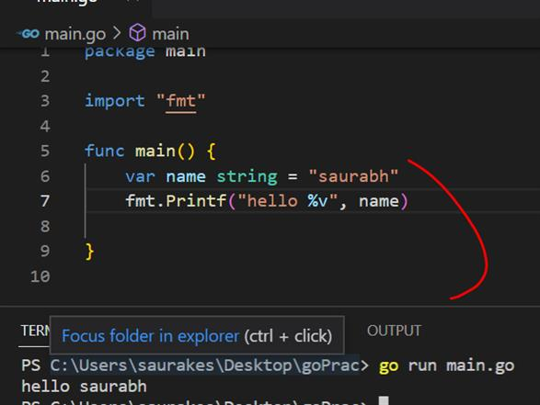

**%d** : format decimal specifier

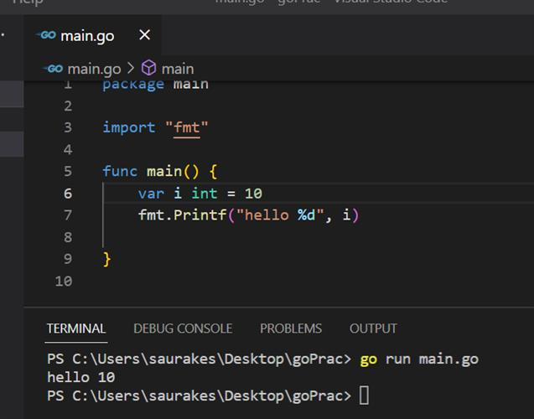

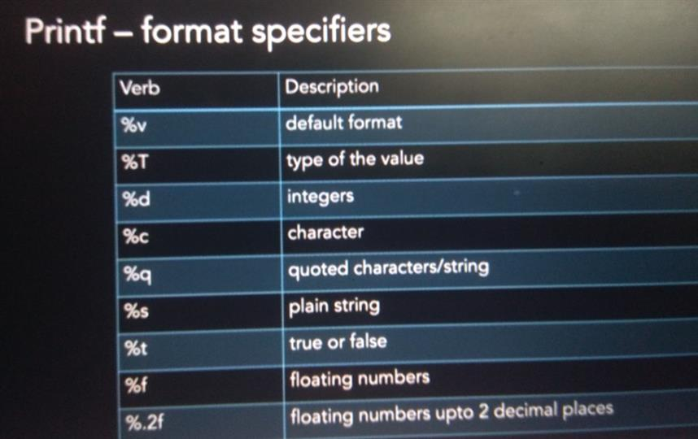

**Declaring variables**

We can declare variable in many ways

**Variable of same type**

**Shorthand way**

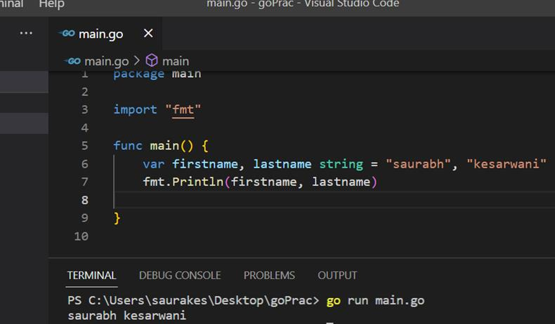

**Variables of different datatype**

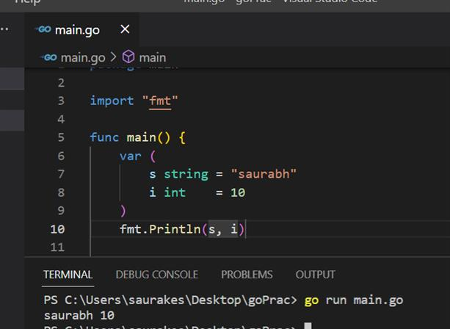

**Short variable declaration :**

S := "hello world"

( there is no need to use var keyword or declare variable datatype)

(successfully declared and initialized string data variable)

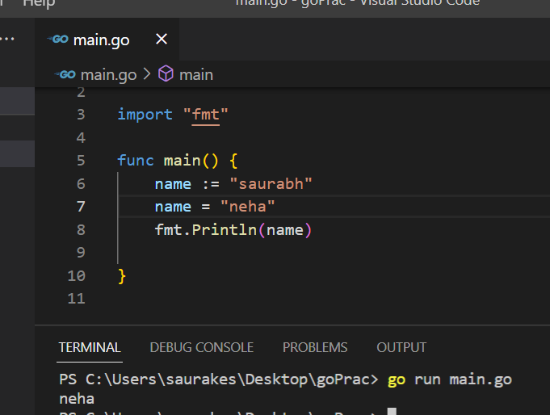

Note :

Even in short variable declaration data type is imp , we cannot assigned to different data type value

**Variables scope**

In golang scope is defined using block ( {})

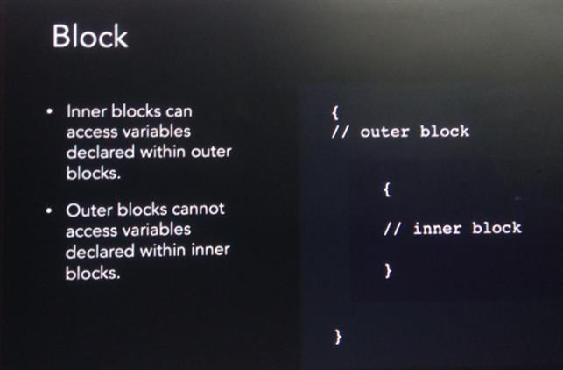

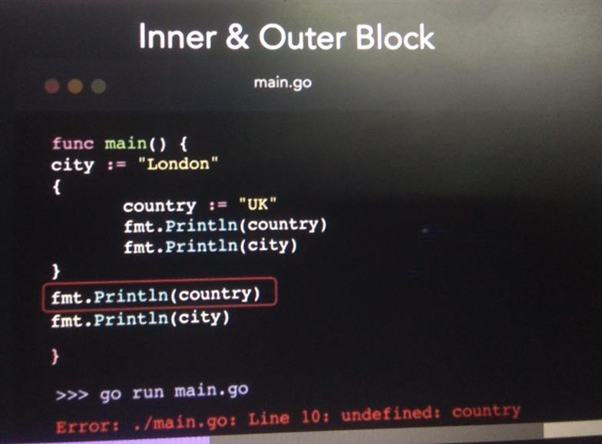

**Local vs global variables**

**Local variable :**

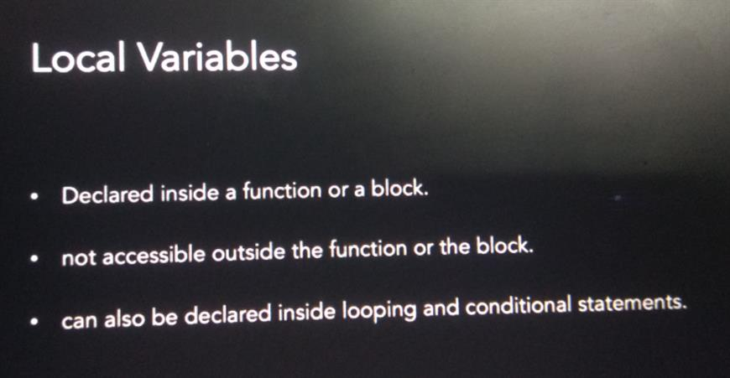

**global variables**

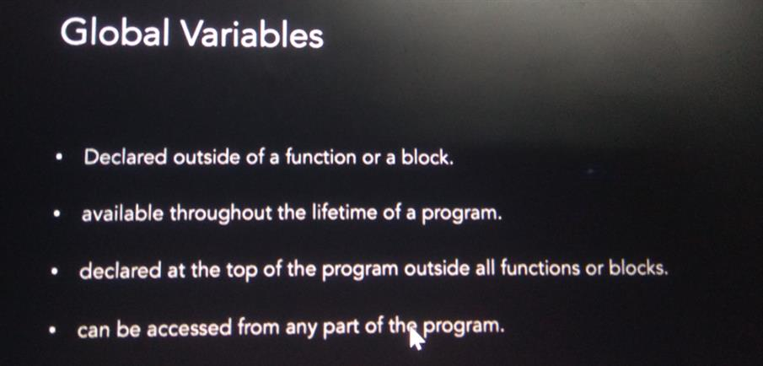

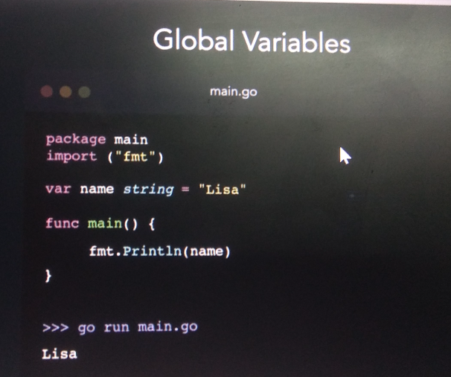

**Zero values**

Default values when we are not initializing

**Bool** false

**Int** 0

**Float64** 0.0

**String** ""

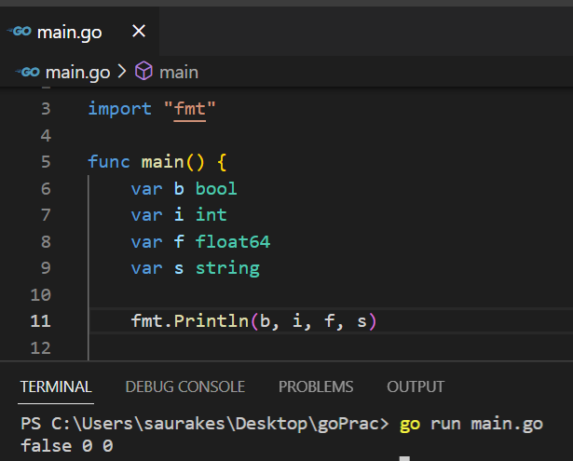

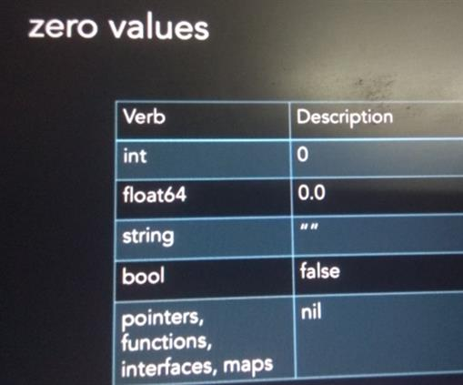

**User input**

**How to read input from user**

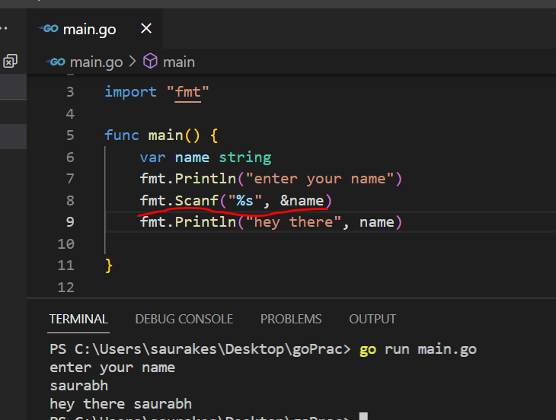

**Taking multiple input using scanner method**

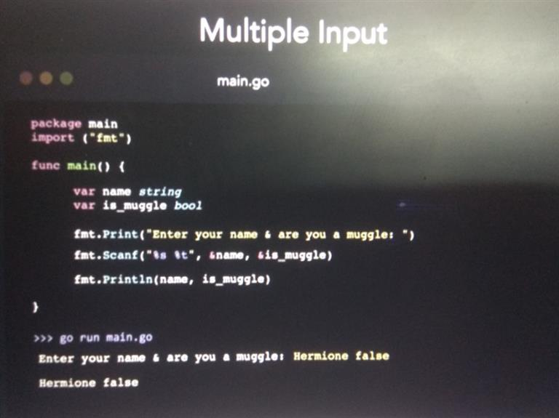

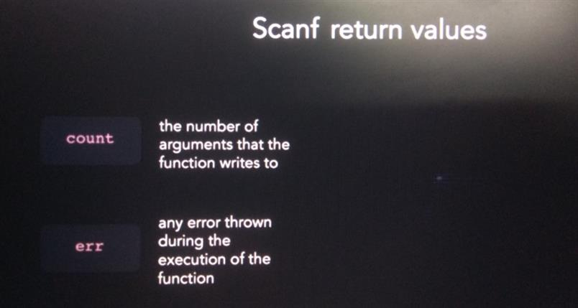

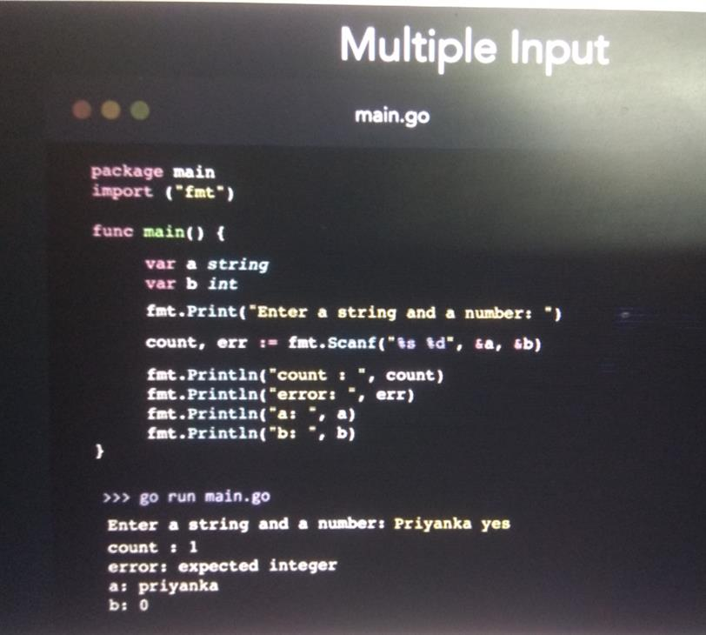

**Find the type of a variable**

**%T :** format specifier

**Reflect.TypeOf :**  function from the reflect package

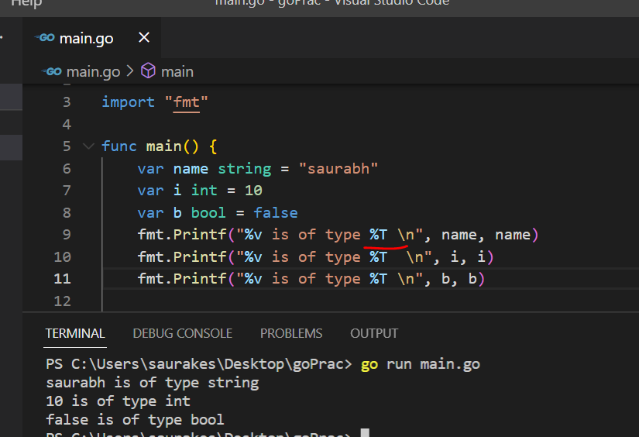

We need to import package **"reflect"**

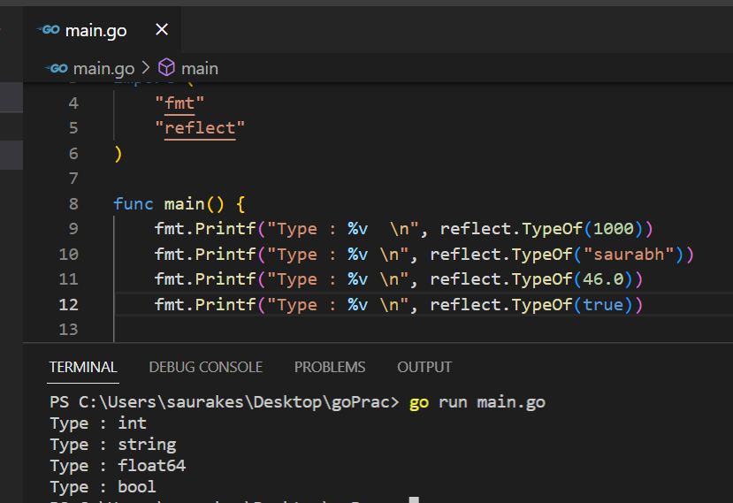

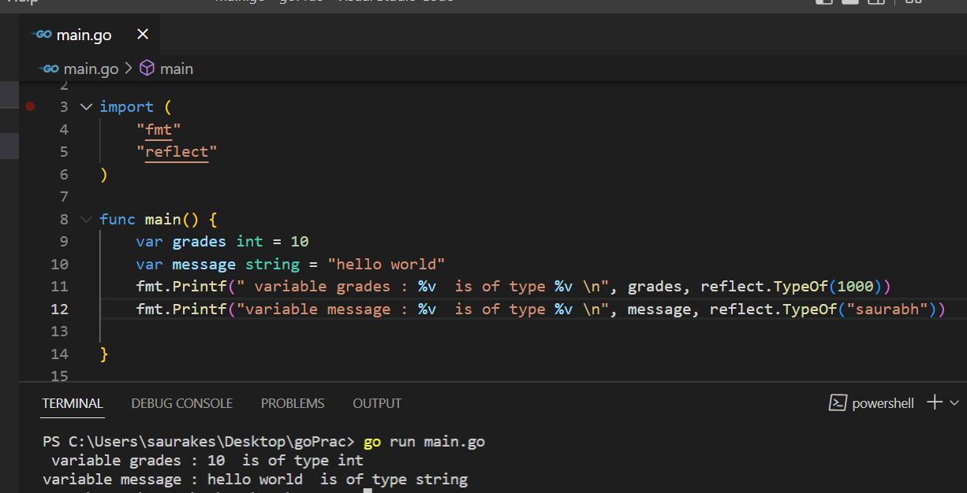

**Converting between types**

**Type casting :**

Process of converting one data type to another

**Converting integer to float**

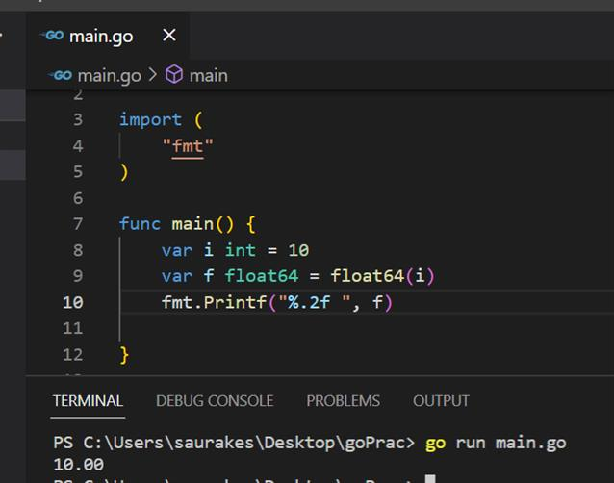

**Converting float to integer but we can lose precision**

It will return just a number before the decimal point

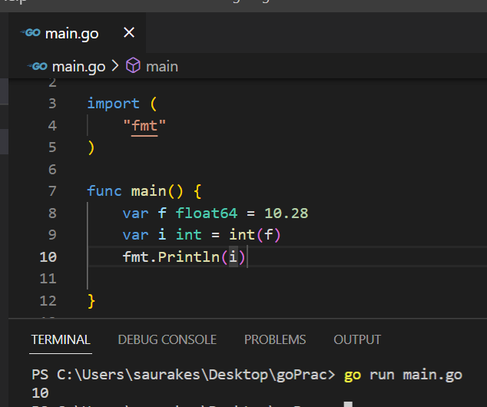

**String conversion package ( strconv package)**

This package contain method which we can use convert to string and vice versa

**Itoa() :**

convert integer to string

Return one value string formed with the given integer

**Integer to string**

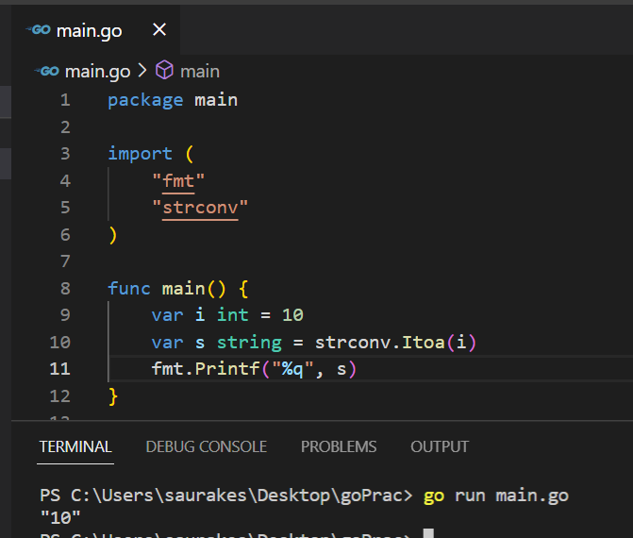

**Atoi()**

**Convert string to integer**

Return two values the corresponding integer , error if any

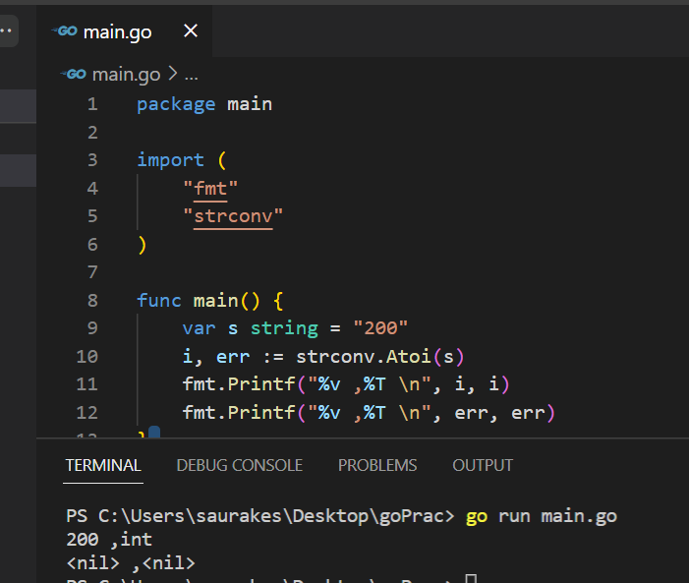

**Note :**

If error is not there we will get nil

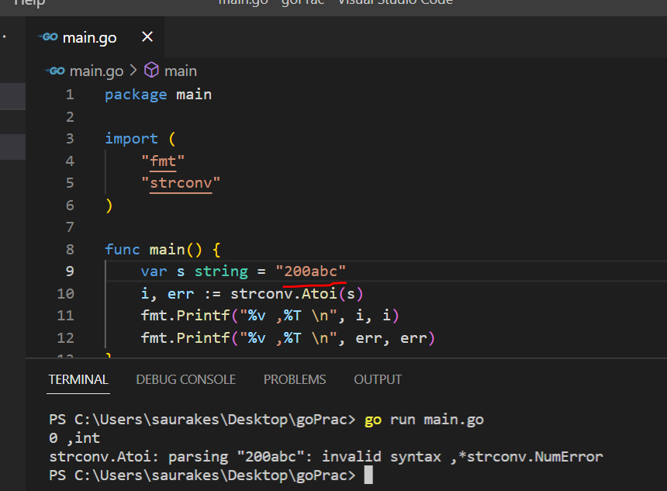

**Constants**

Whose value once initialized cannot be modified

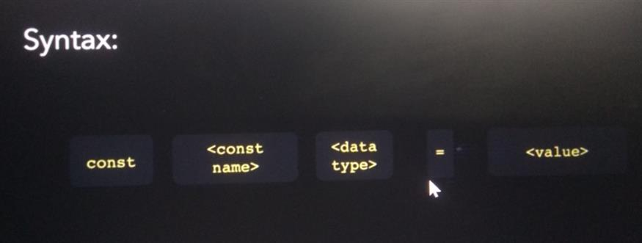

**Two types**

**Untyped**

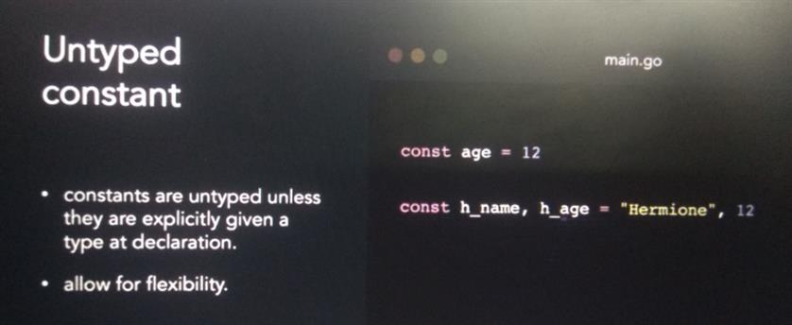

**Typed :** explicitly defined data types of constant

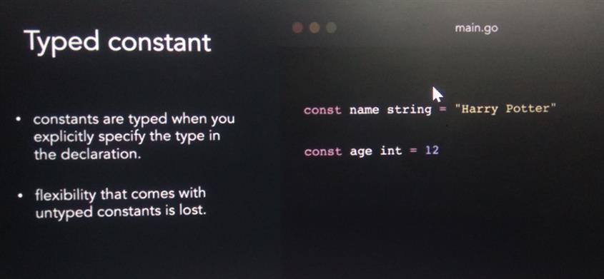

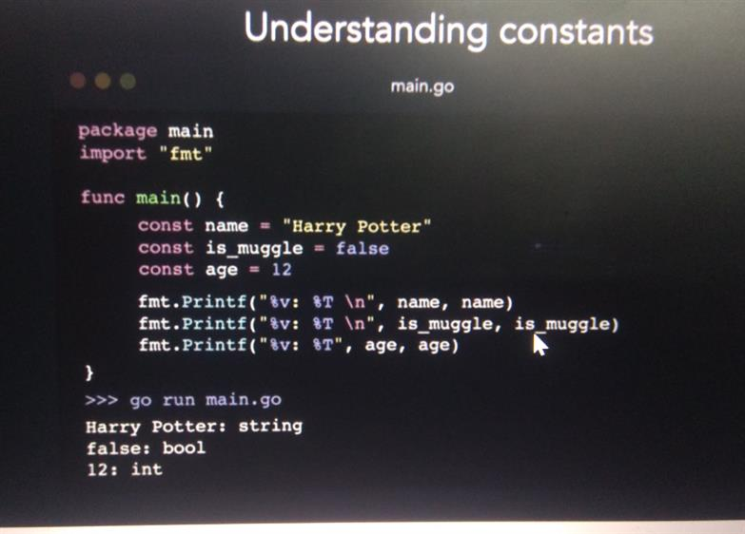

**Note :**

We need to declare and initialize constant at the same time

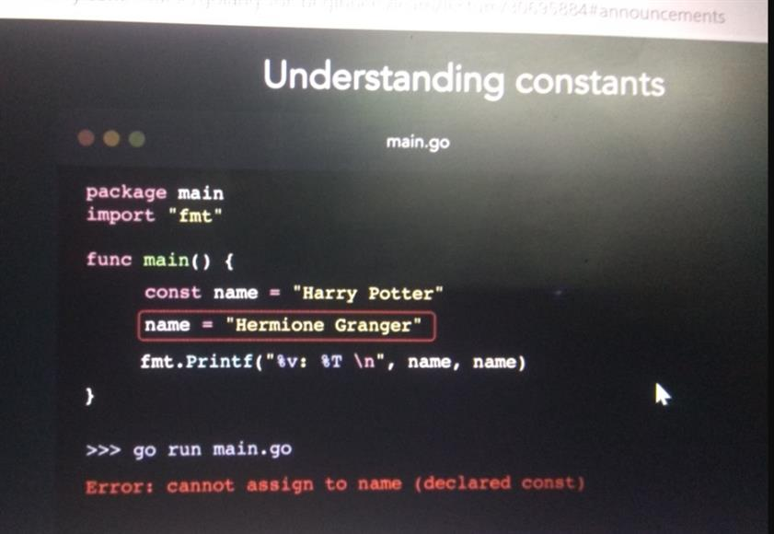

**Short hand assignment will not work for constant**

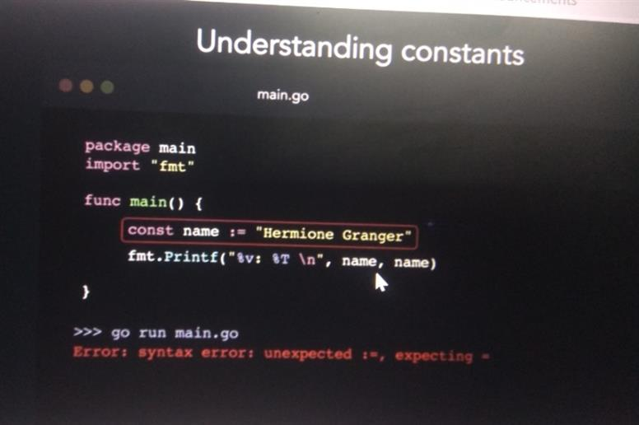

**Usecase : area of circle (pai)**

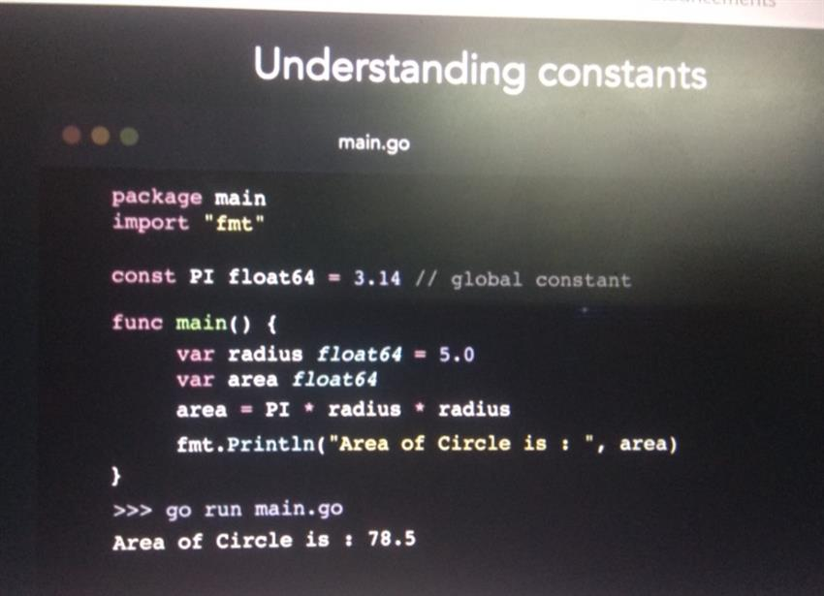

Section 3: Operators and Control flow

**A + b** ( a and b are operands and + is operator)

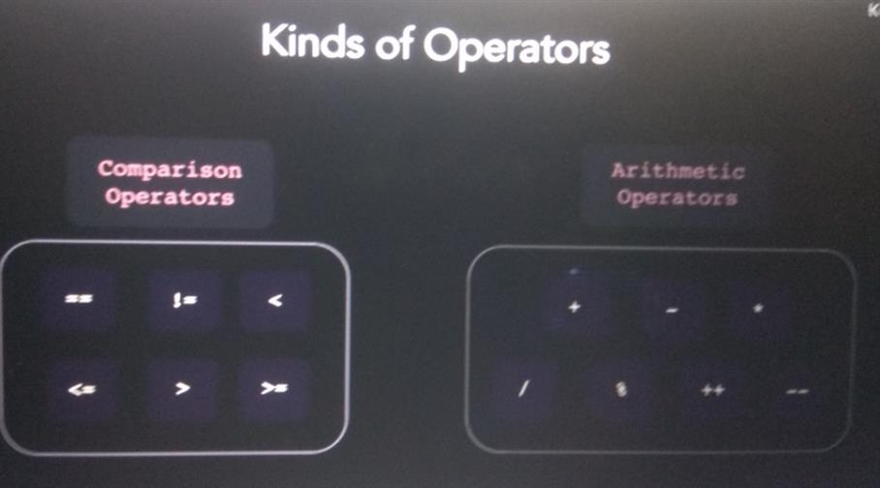

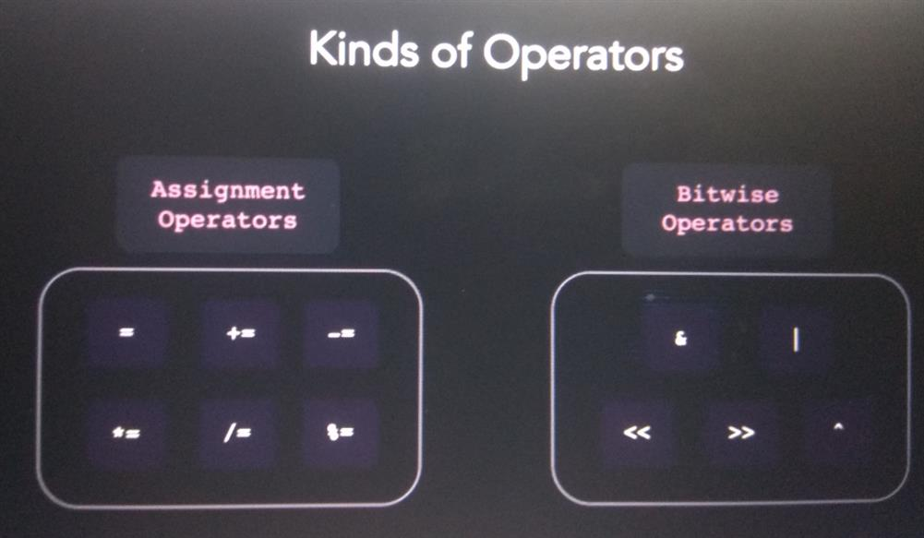

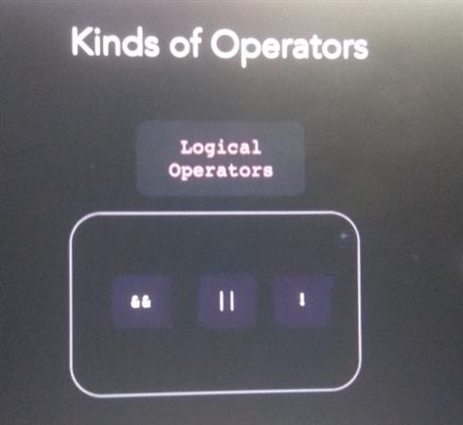

**Comparison operator**

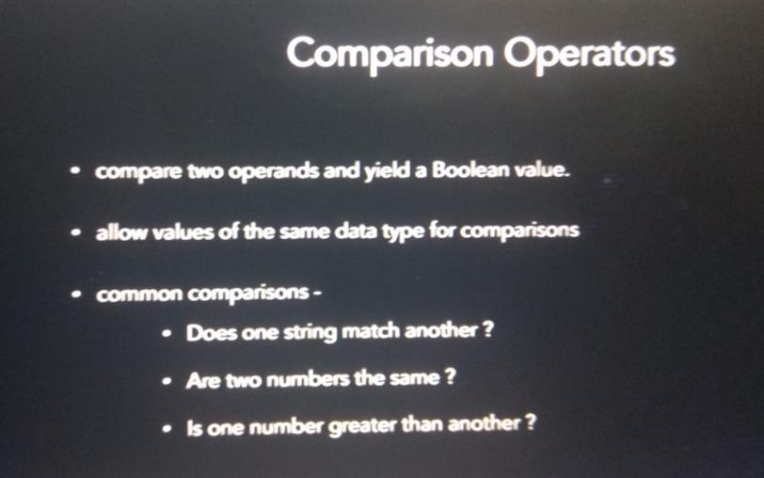

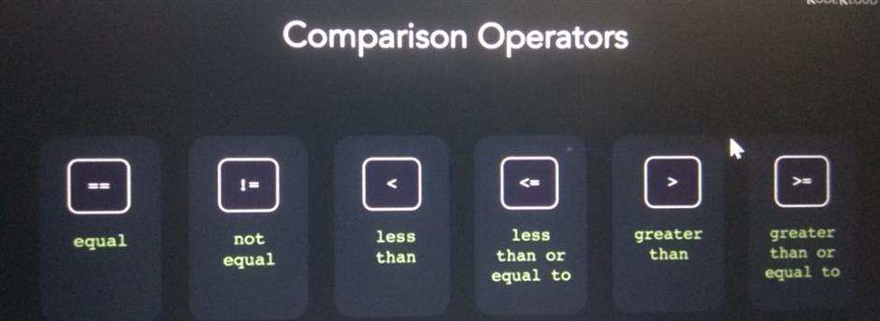

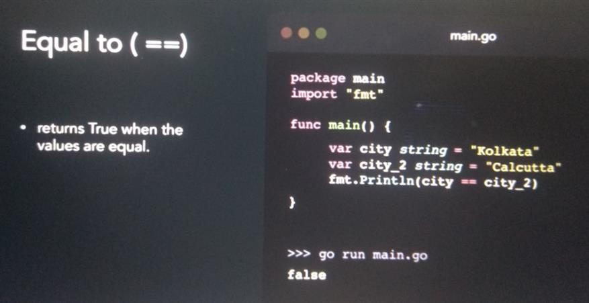

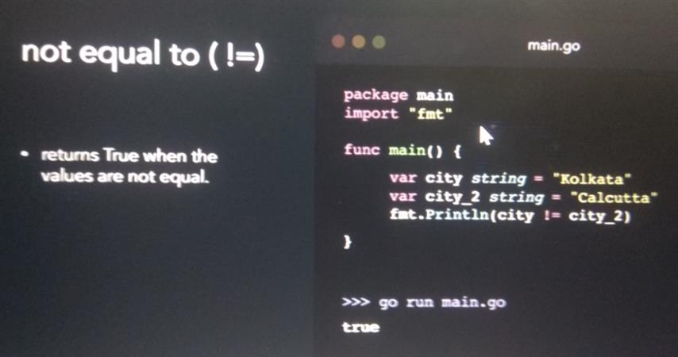

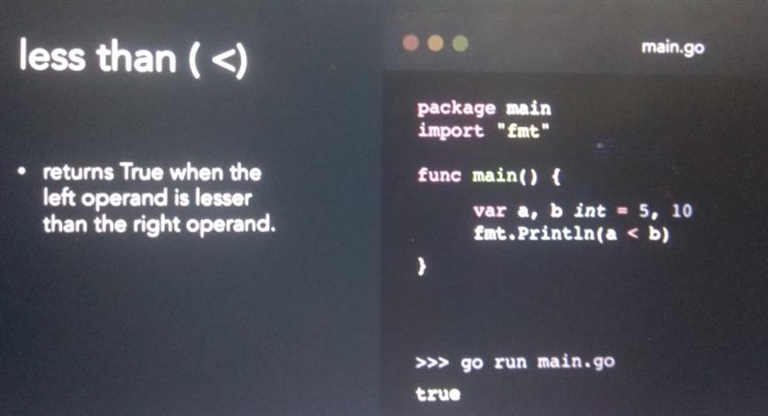

**Arithmetic operator**

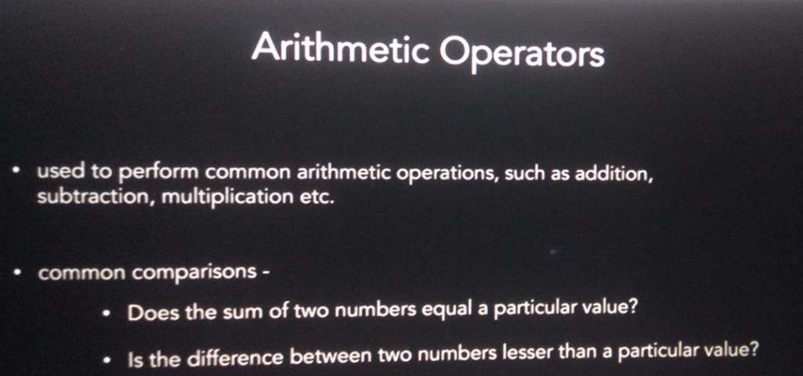

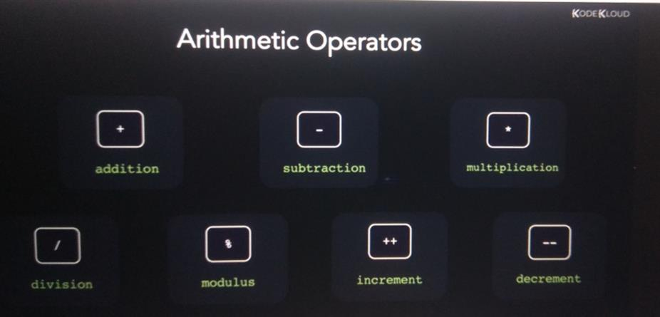

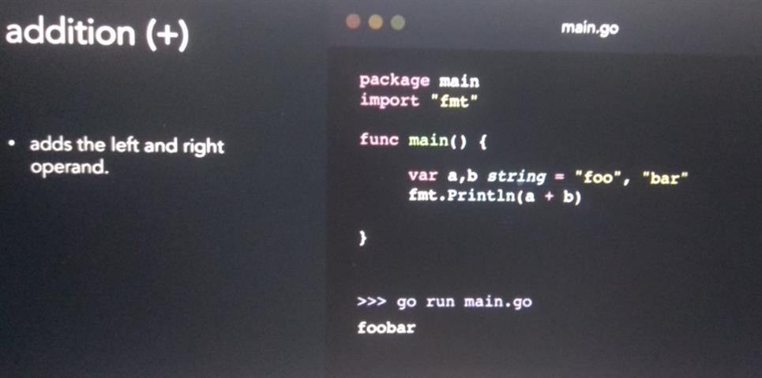

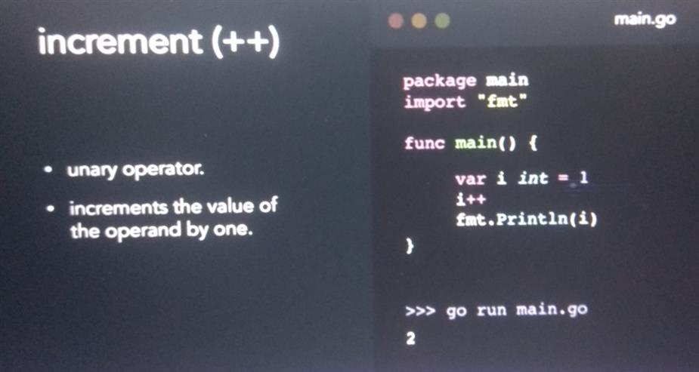

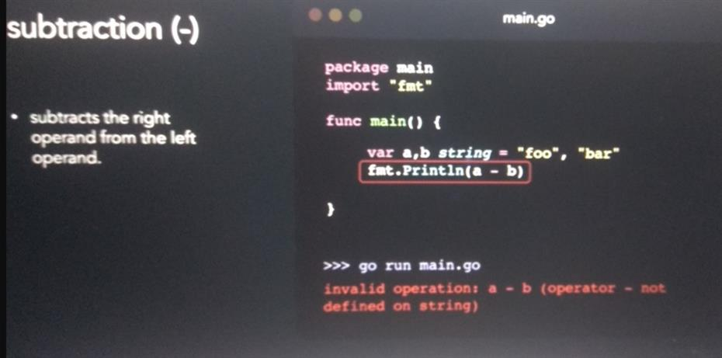

**Logical operator**

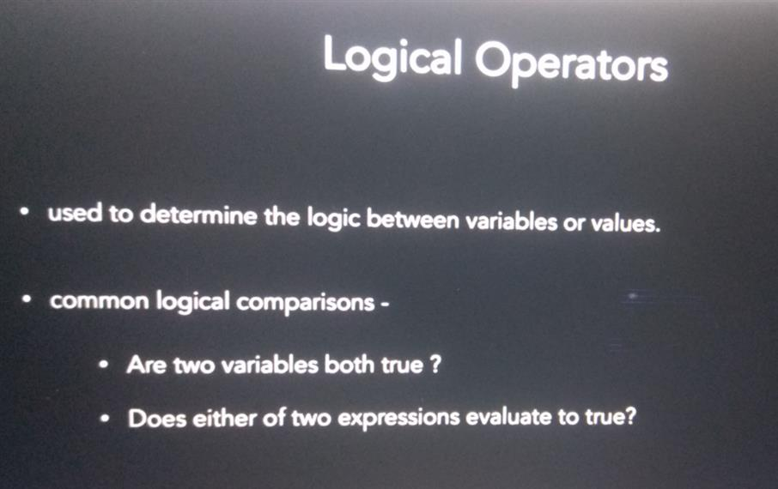

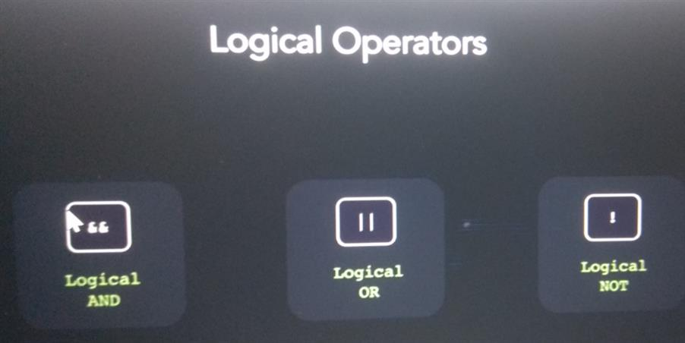

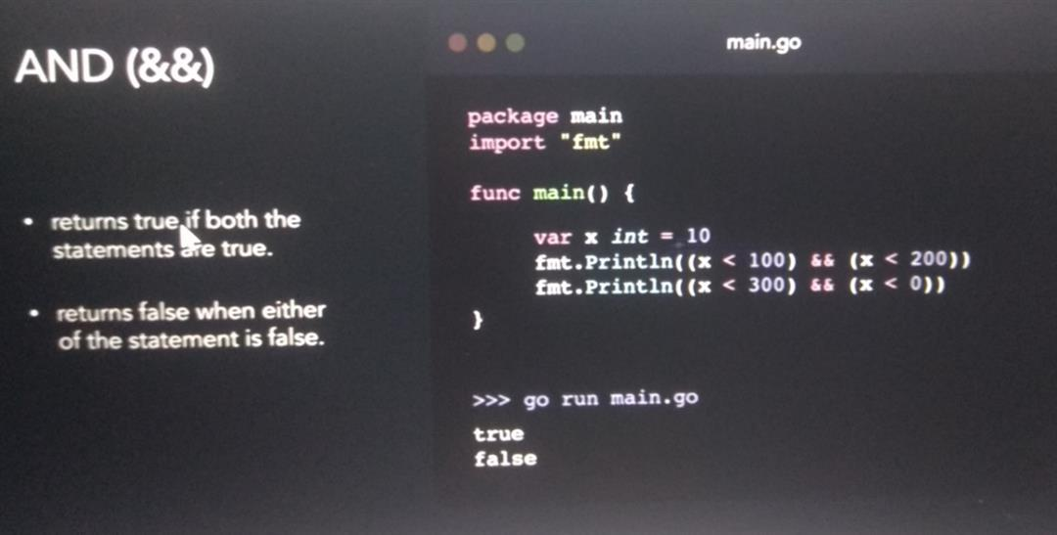

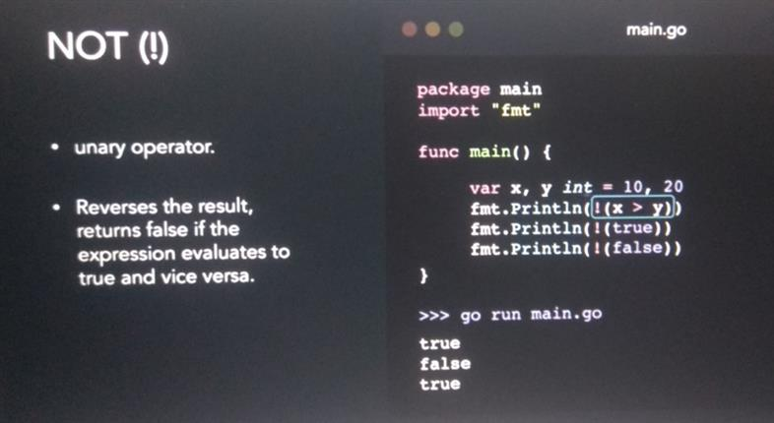

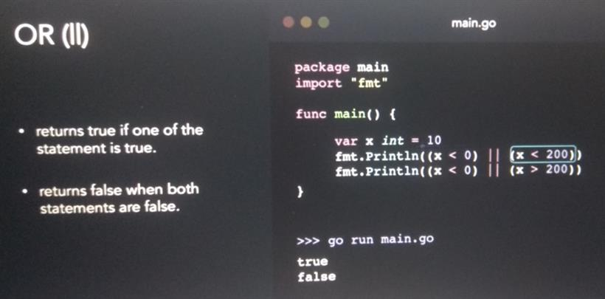

**Assignment operators**

x+=y means x=x+y

x-=y means x=x-y

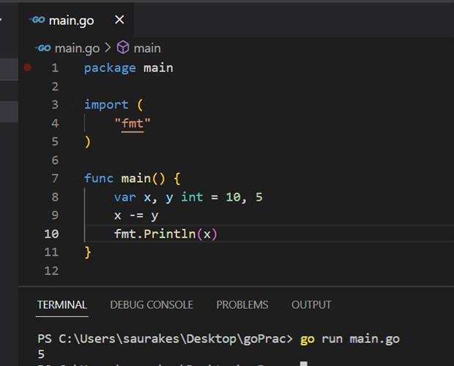

**Bitwise operator**

It will perform bit by bit operation

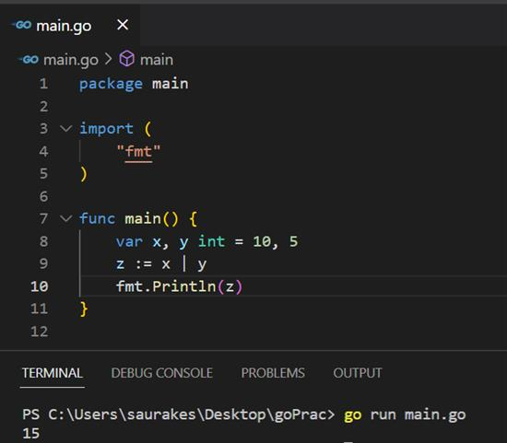

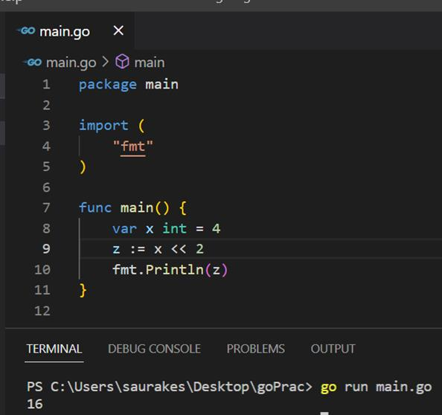

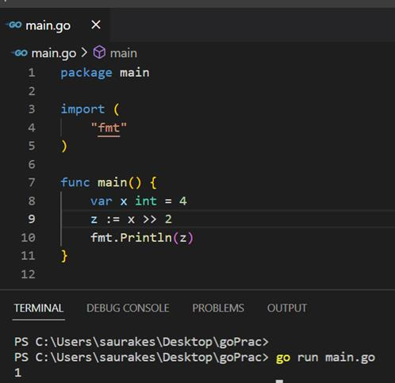

**==================================================================================**

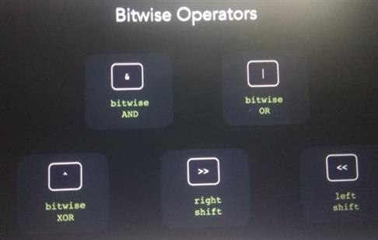

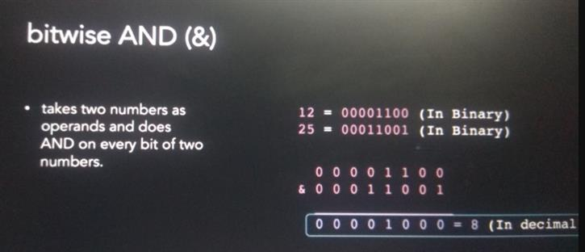

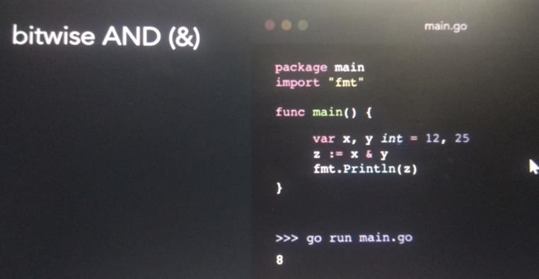

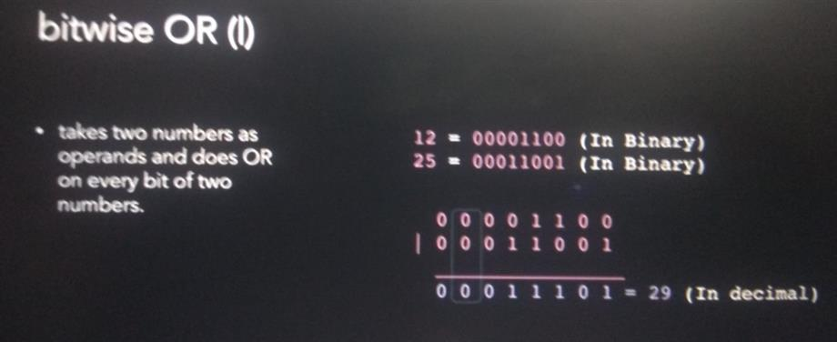

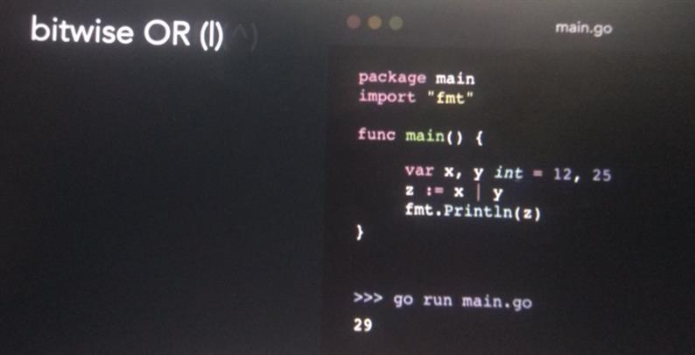

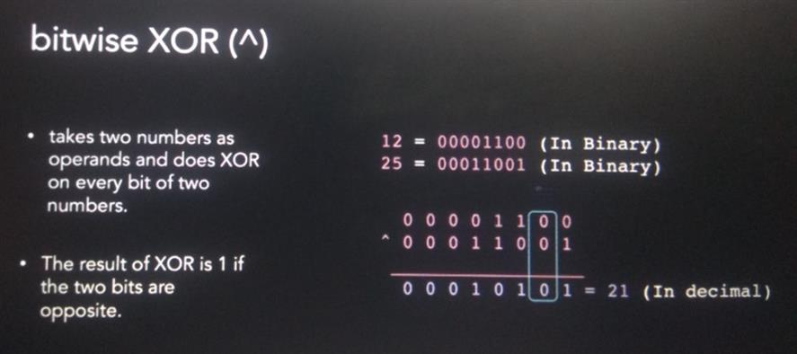

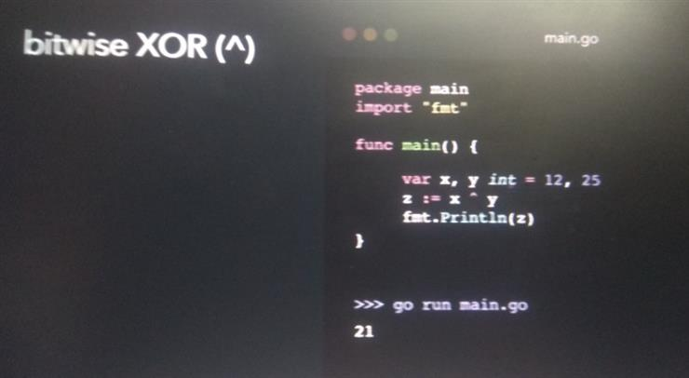

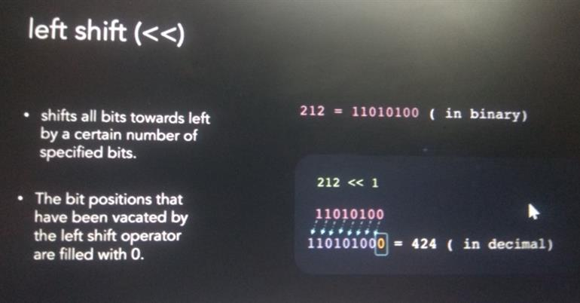

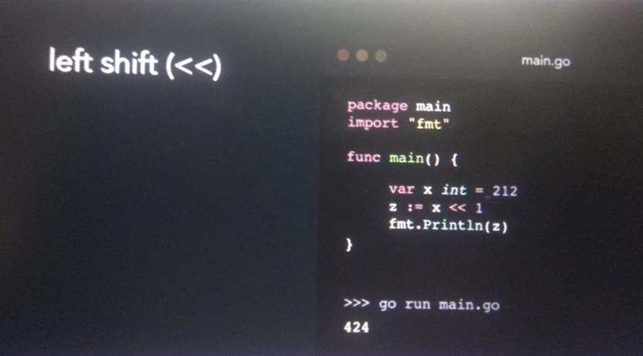

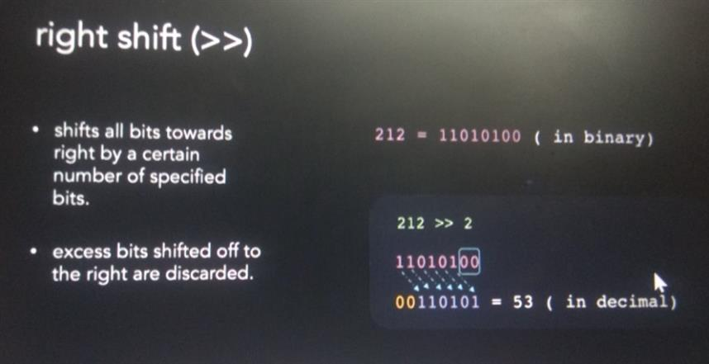

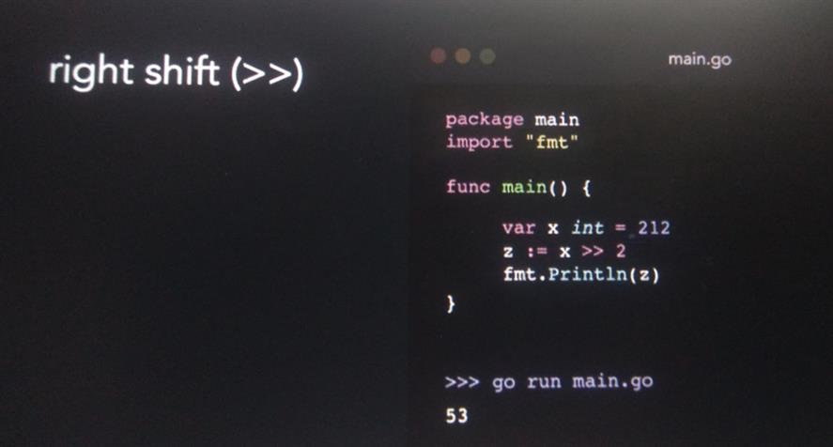

**If else and else if statement**

Parenthesis around the condition are optional

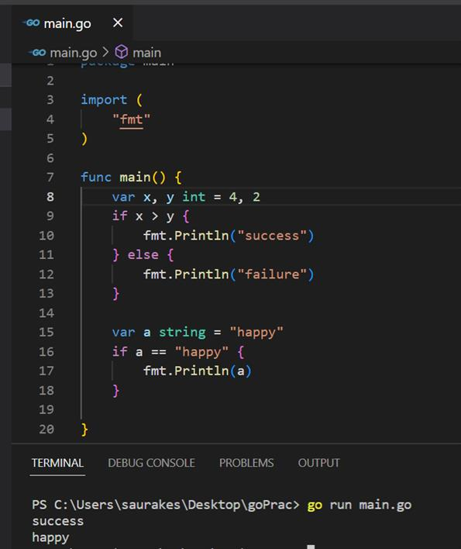

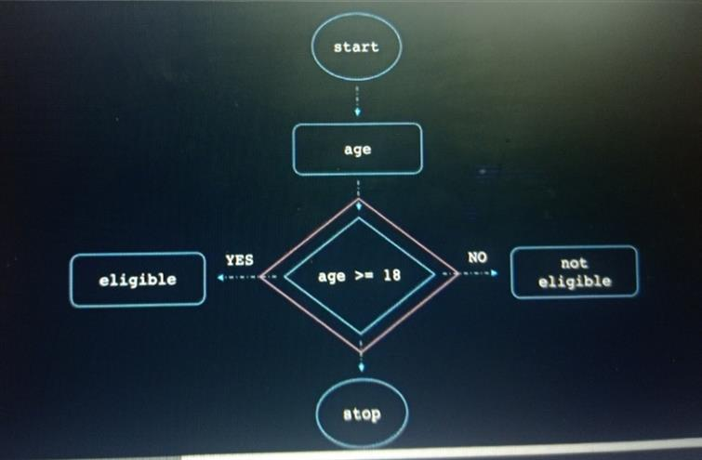

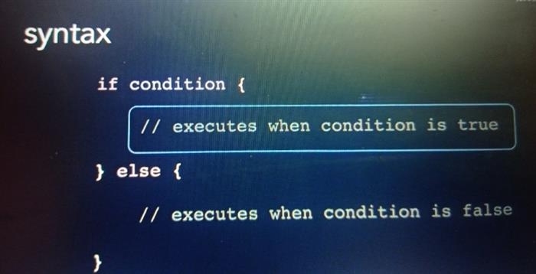

**Switch statement**

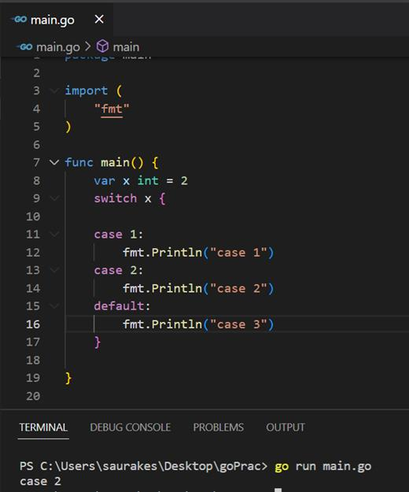

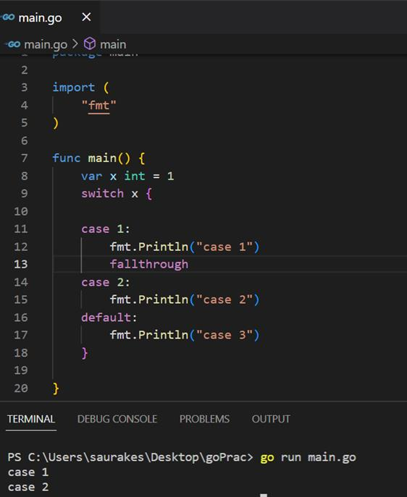

We can define condition statement also in switch case not need to put explicitly break

**================================================================================**

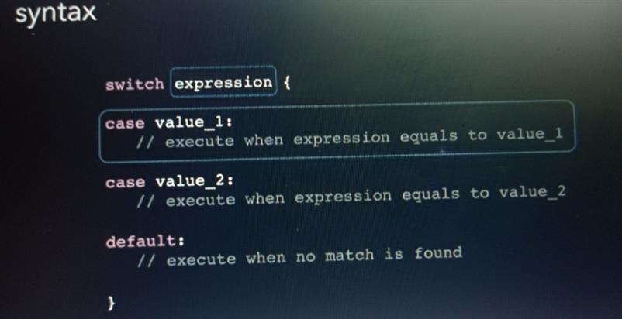

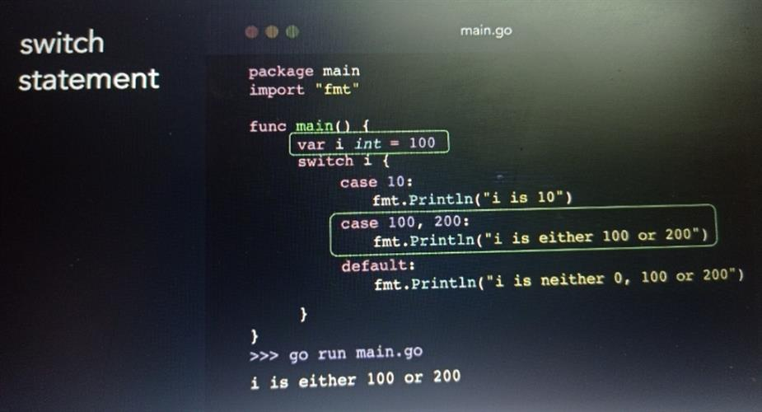

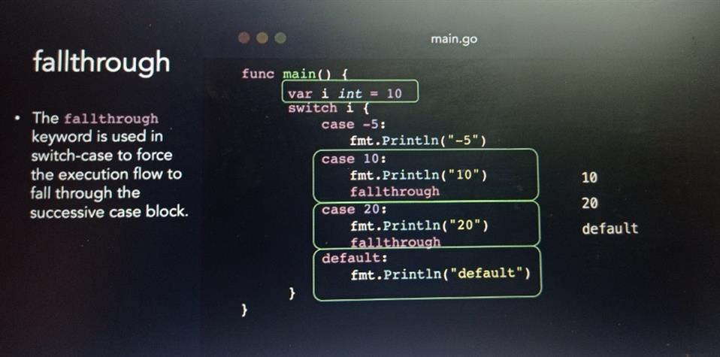

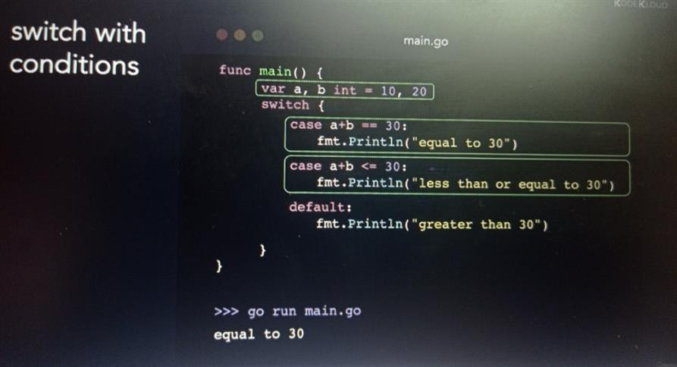

This is because go uses implicitly break statement in each case

**Looping with for**

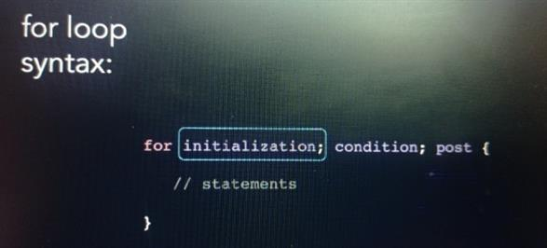

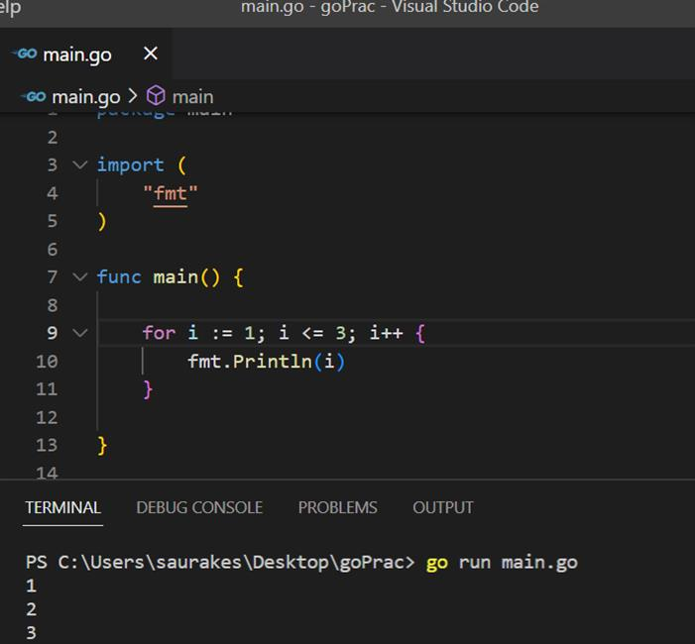

**Initialization and post statement is not included in loop**

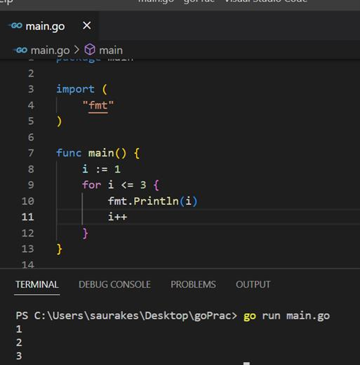

**If we skipped condition will get infinite loop**

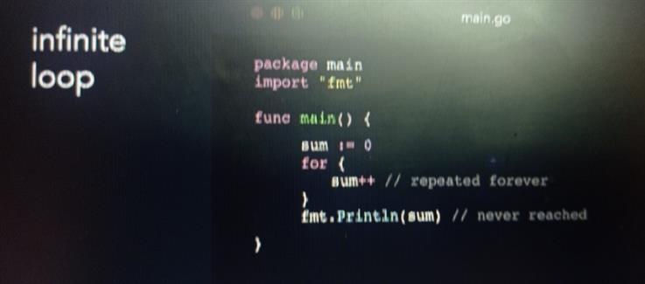

**Break and continue**

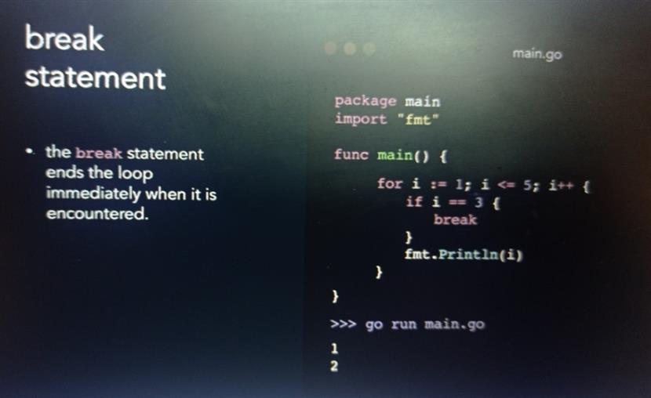

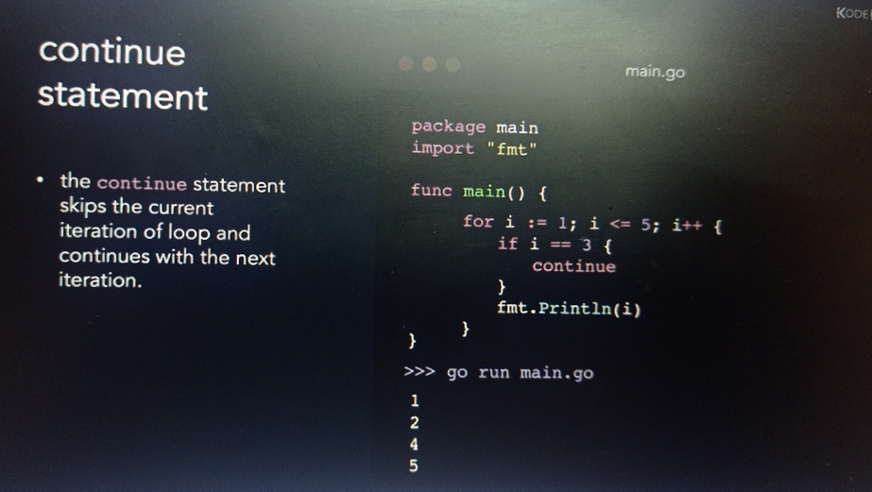

Section 4: Arrays slices and maps

Arrays : is a collection of data element of same data type

**Homogeneous data type** : since we can store same data type in array

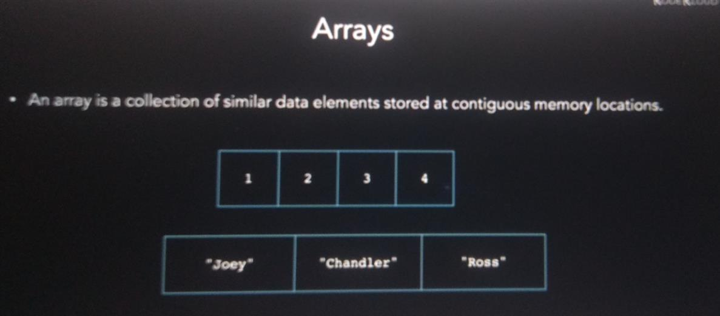

**Note :**

In case of array length and capacity is same

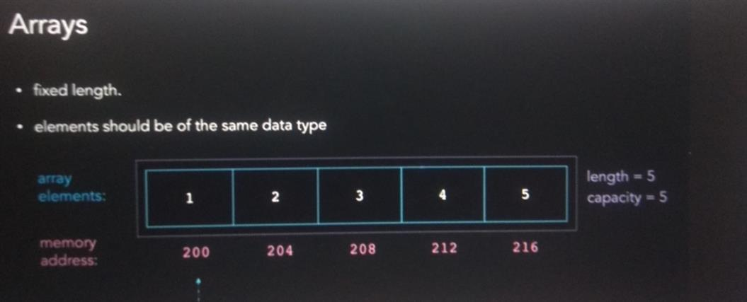

**Array declaration**

Var arr[10] int

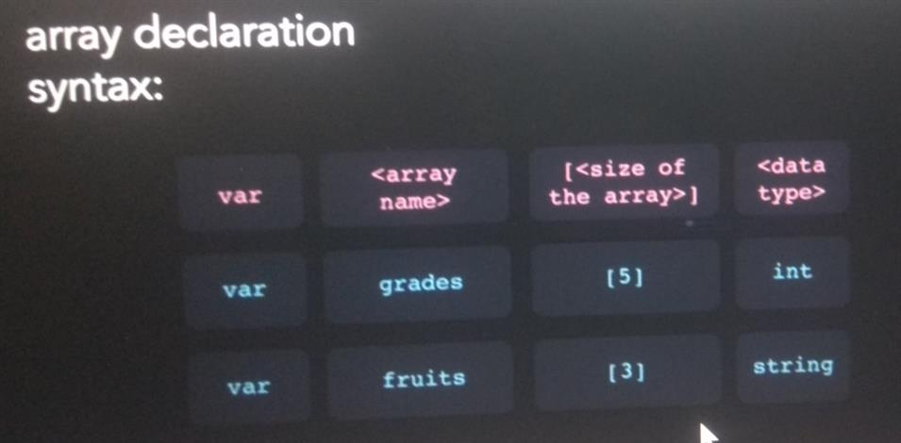

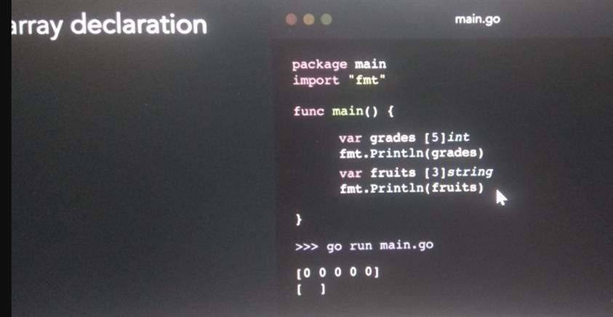

**Initialization of array**

Number of value should always be less than or equal to size of the array

**Grades:=[…]int{10,20,30}**

We need not specify the size or length of the array

Compiler will implicitly calculate the length of array based on the number of element specified here

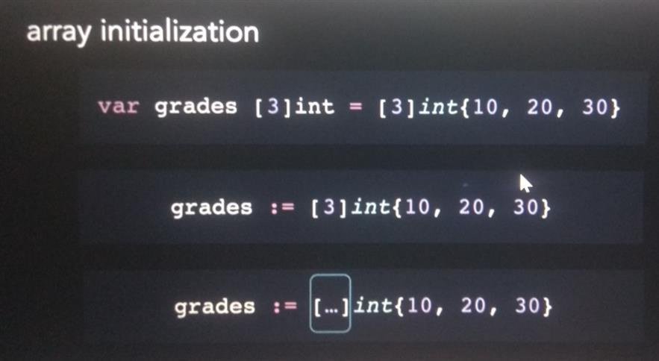

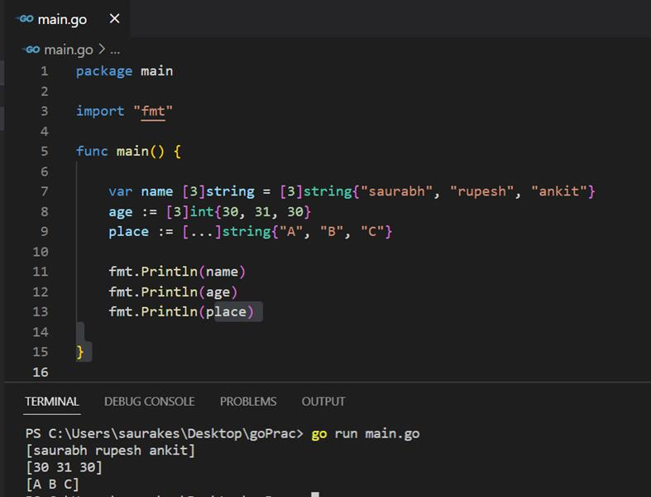

**Find size of an array : len()**

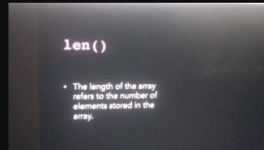

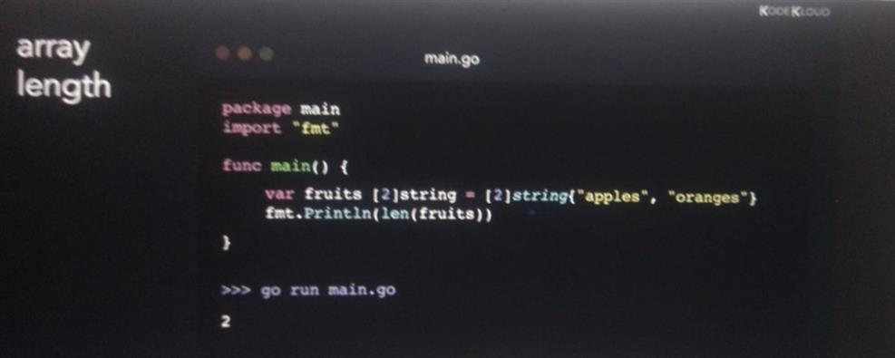

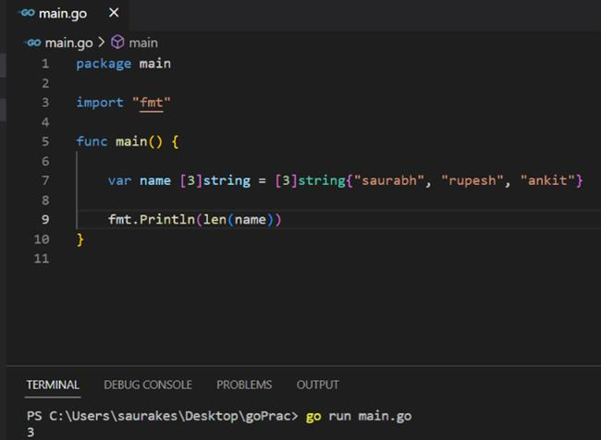

**Indexes in array :**

**We can access array element using these indexes**

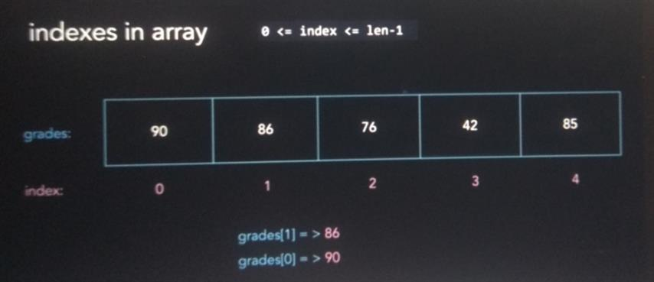

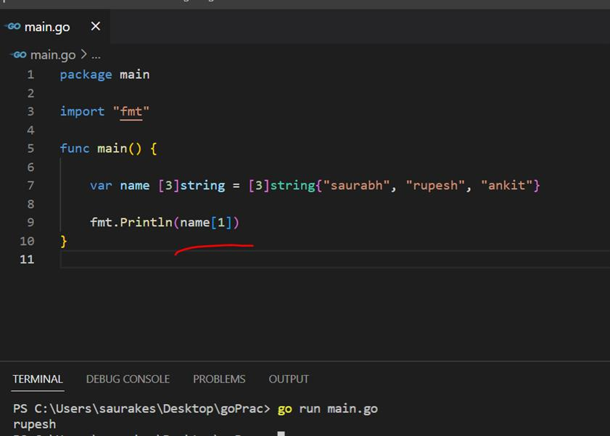

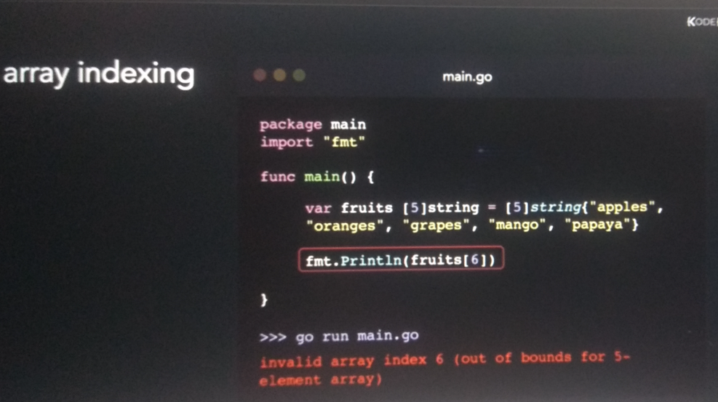

**Changing the value of index**

**Loop an array:**

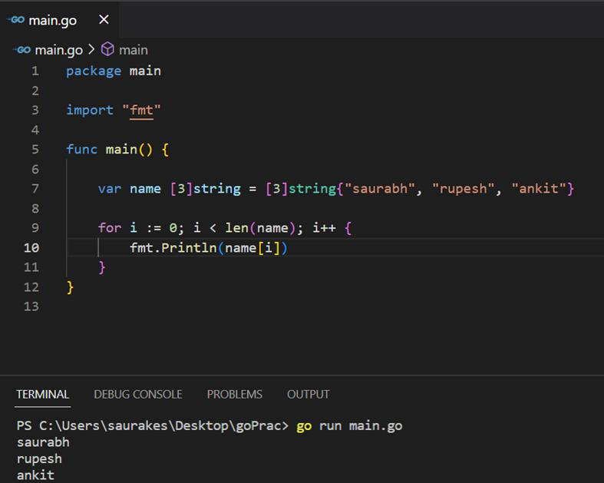

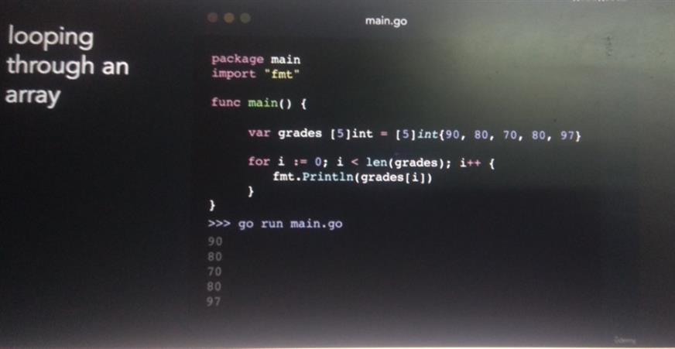

**Iteration using range keyword**

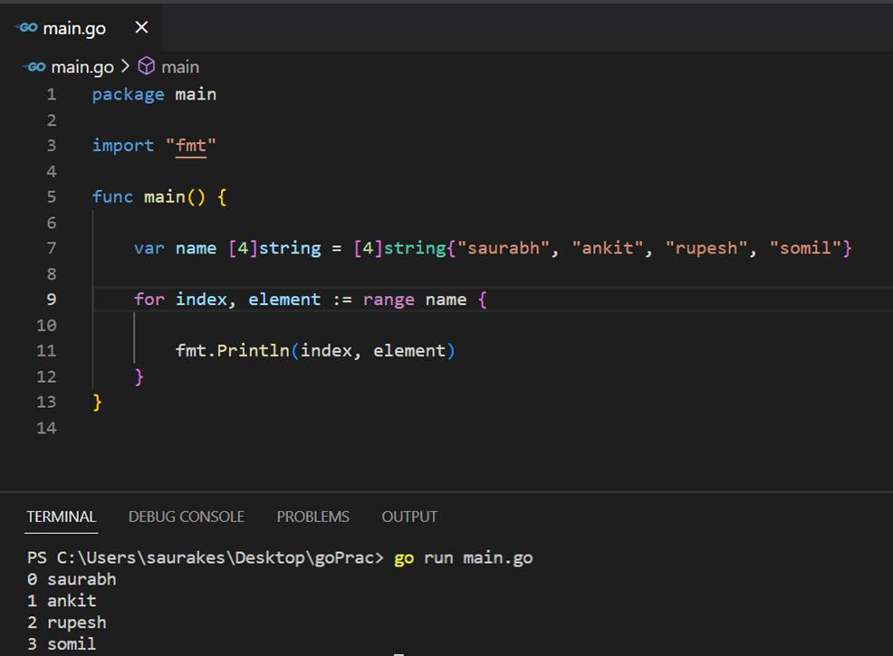

**Multdimensional arrays**

3 refers size of the array but 2 refers size of each element in itself

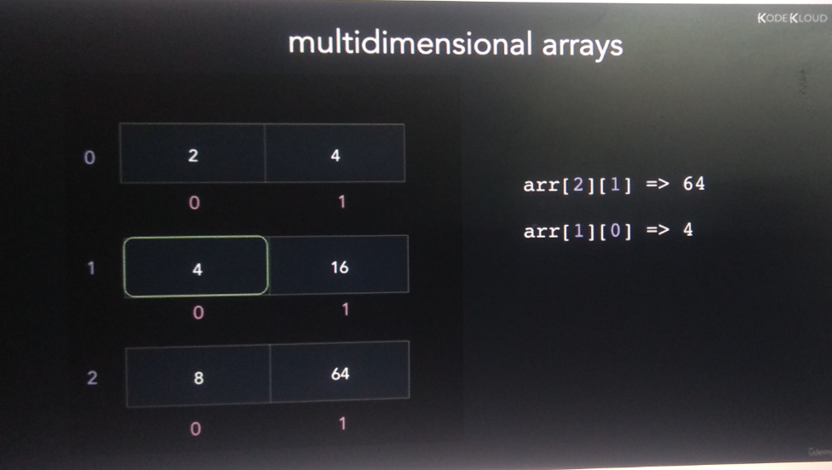

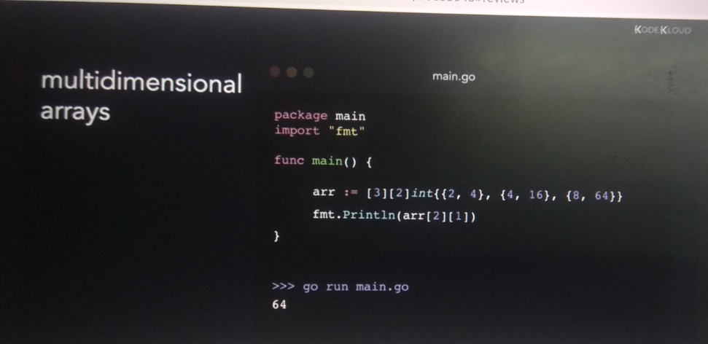

**Slice**

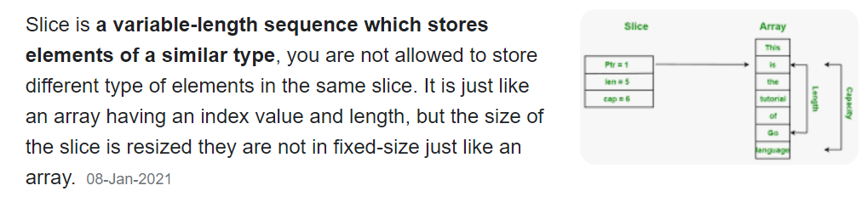

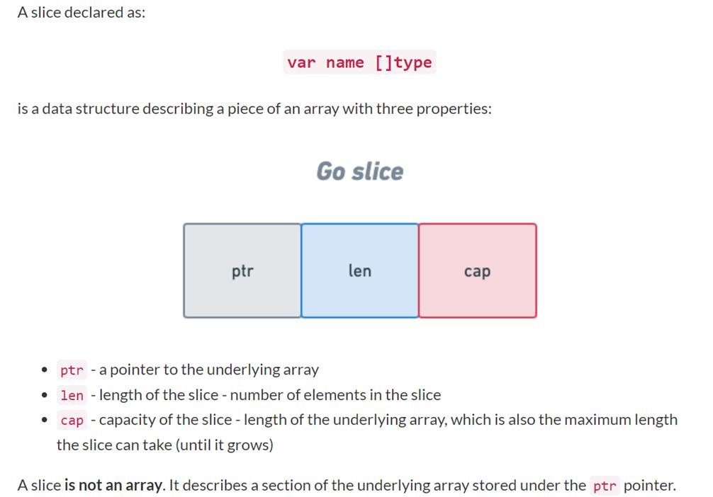

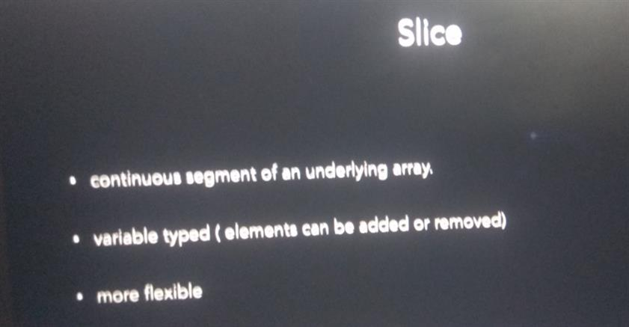

**Here we want to start slice from index 1**

Slice have both length and capacity

Length of slice is number of element it contains --**-(obtained from len()**

Capacity is number of element in the underlying structure point from first element in the slice**(cap()**

**Declaring and initialize a slice**

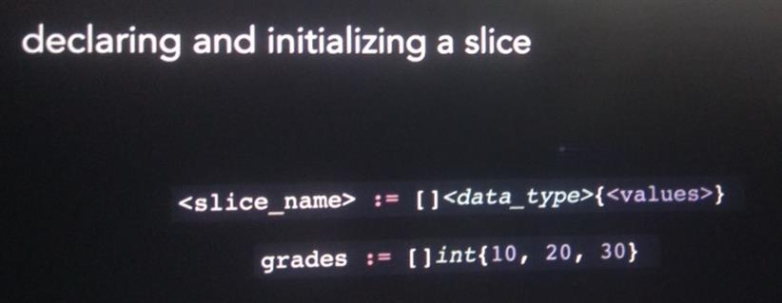

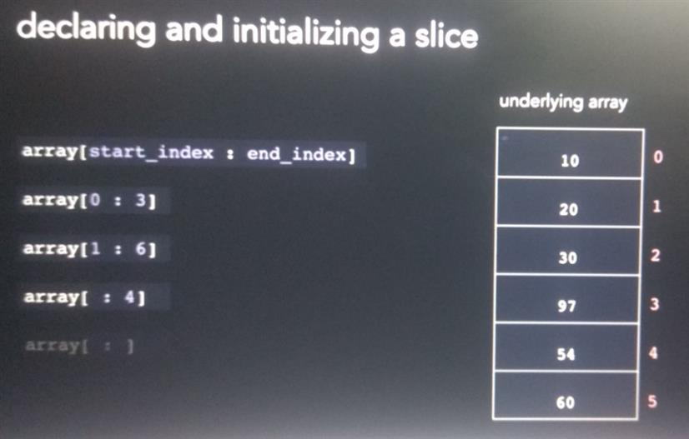

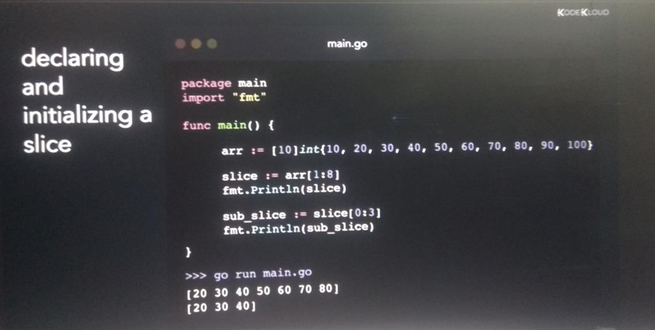

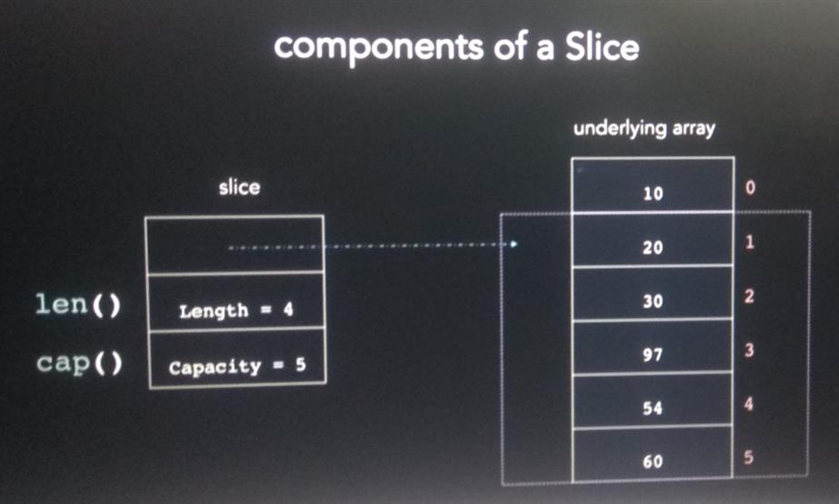

It is similar to array except we don’t need to declare size of the array

Array will created first and after that slice reference Is return to it

**Note :**

Element of start index is included and end index is not included

If we didn’t defined starting index it is 0 by default

Not defined both upper and end the complete array will be sliced

**We can initialize slice with another slice**

**One more way declaring and initializing a slice**

**Note:**

**Capacity is optional**

**Note :**

Slice is reference to the underlying array

When we create a slice get it own numbering or index number

**But when we change value in slice it will get effected in underlying array as well**

**Appending to a slice**

**First parameter :** slice of some data type

**Second parameter :** value of same data type

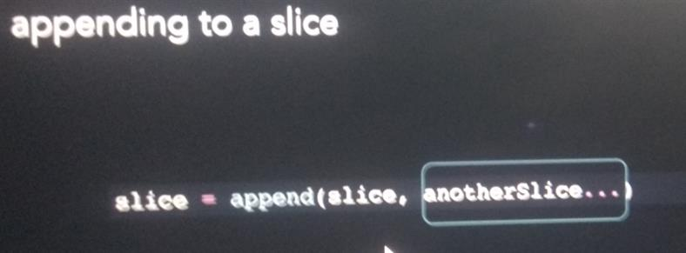

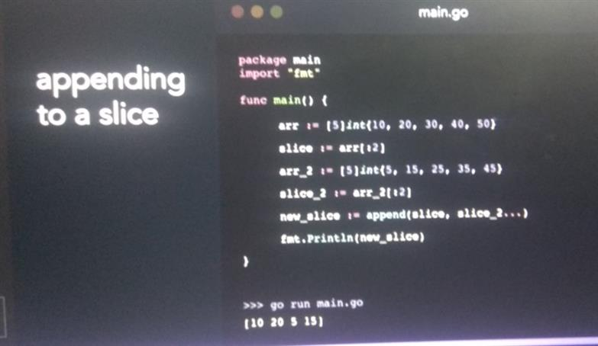

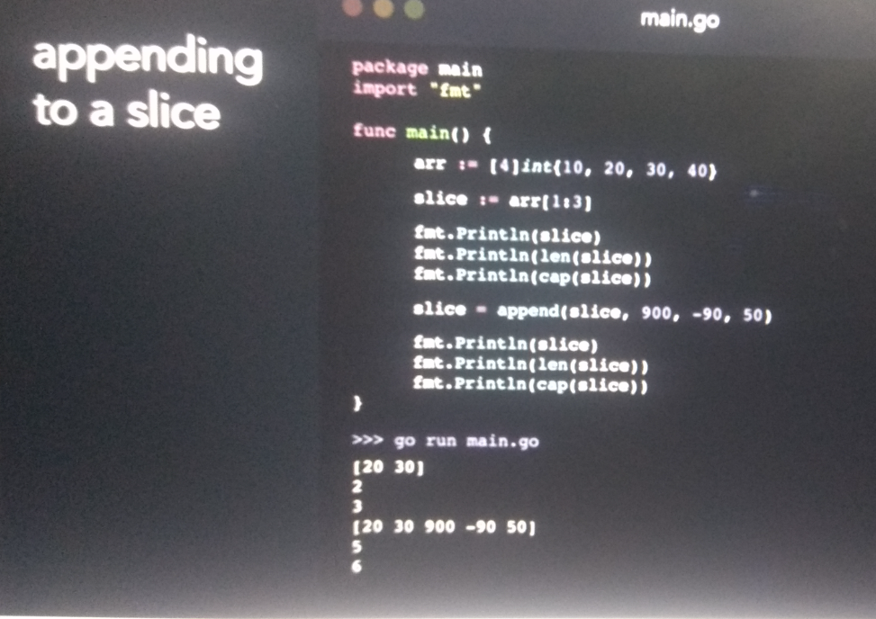

**Result :** contain original slice plus provided value

**New capacity** : underlying array size * 2

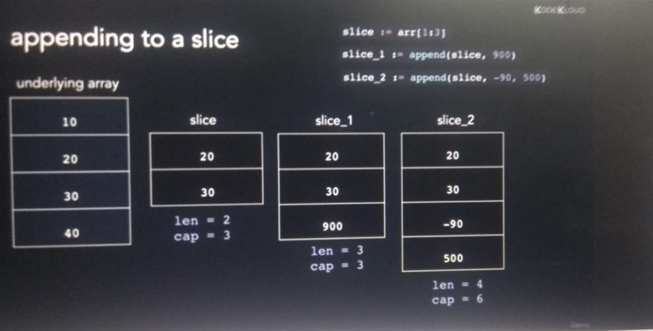

**We can append slice to another slice**

**Delete element from a slice**

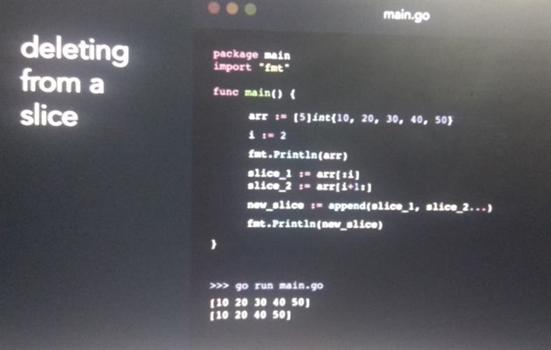

**Copy element from one slice to another**

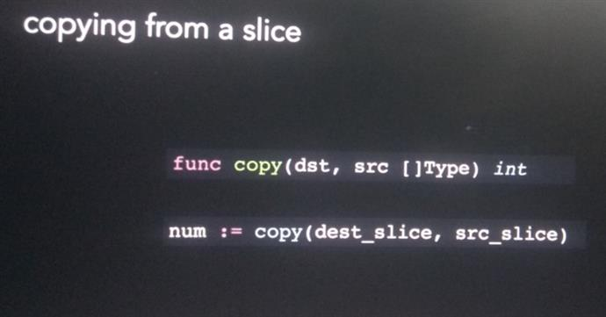

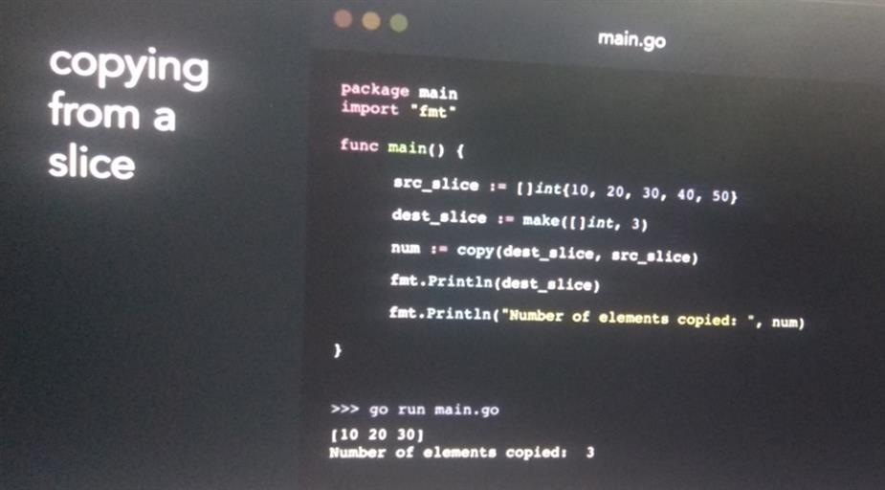

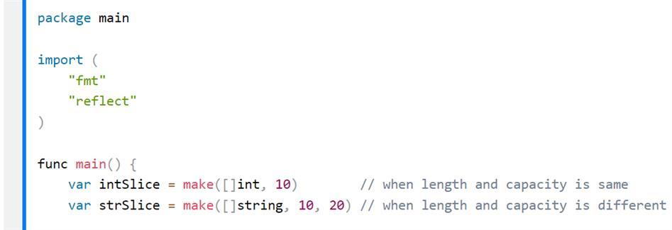

**Lopping through a slice**

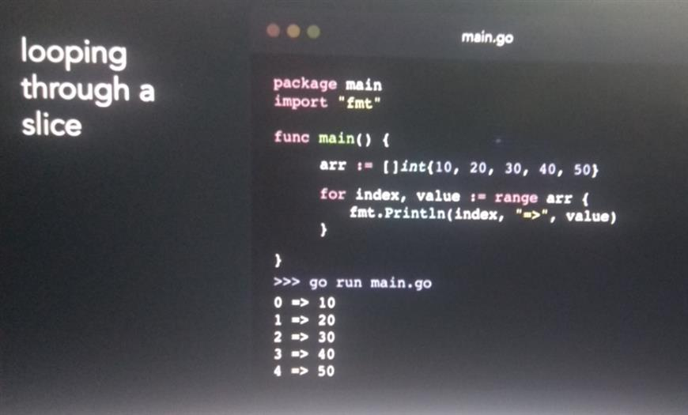

**Maps**

**What is map**

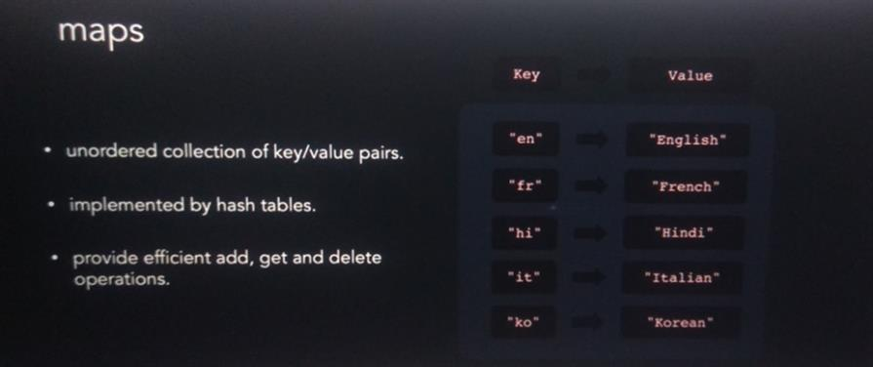

**Declaring and initializing a map**

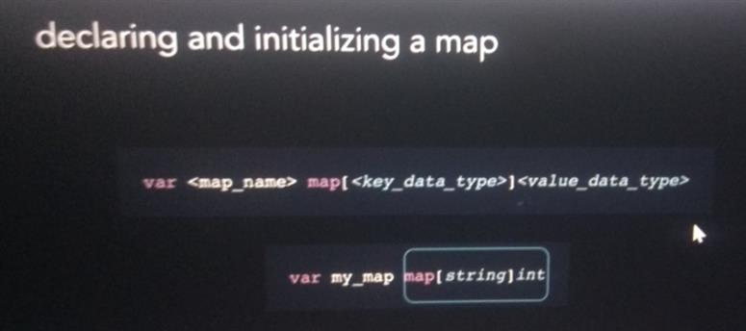

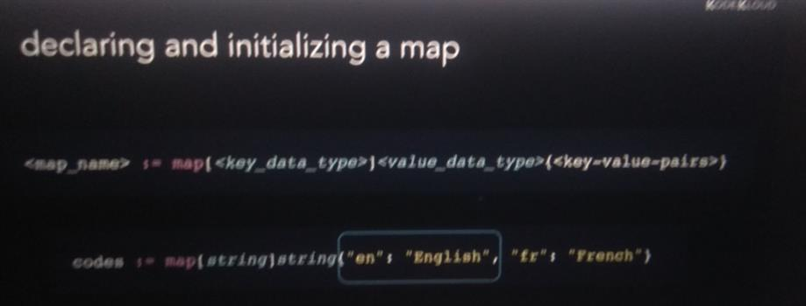

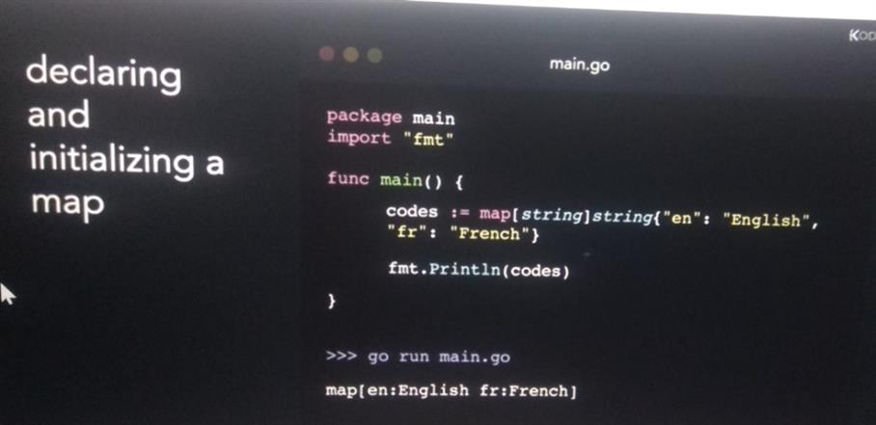

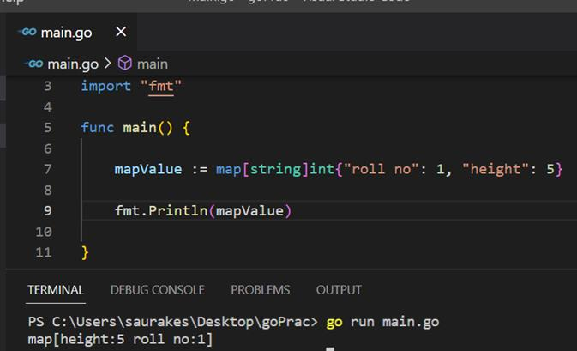

**Declaring and initialize a map using a make function**

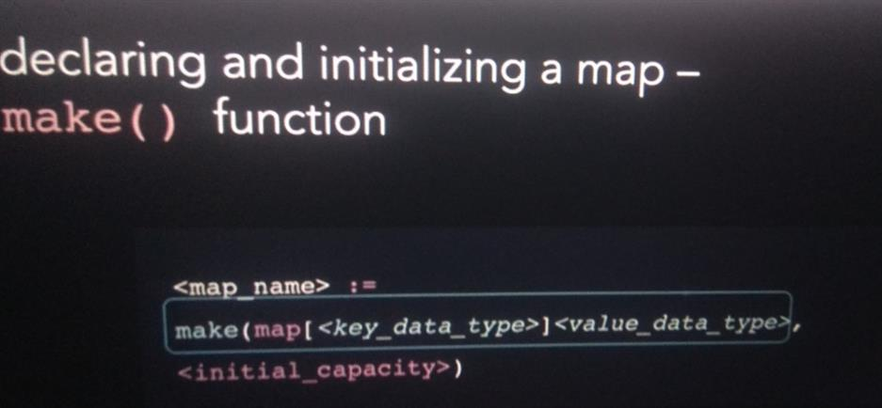

**Initial capacity is optional argument**

**We cannot add key value pair in nil map**

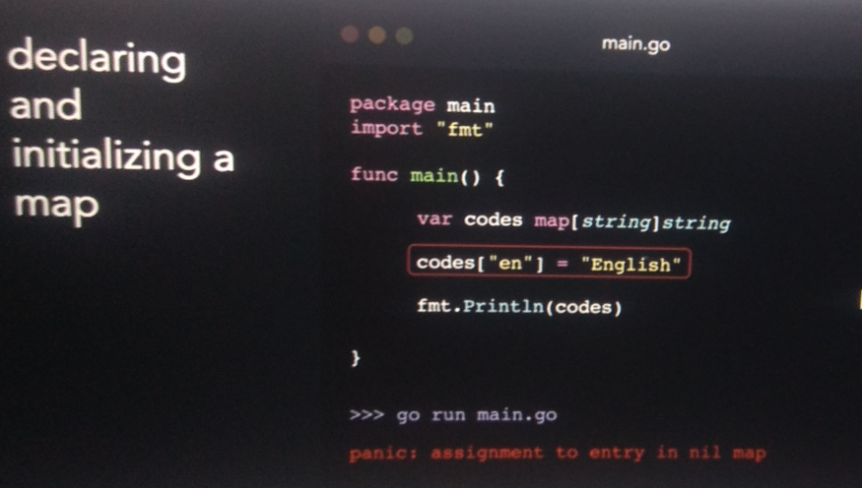

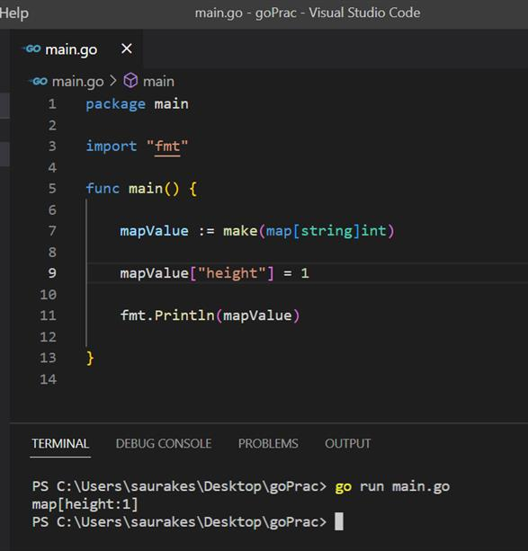

**Accessing a map**

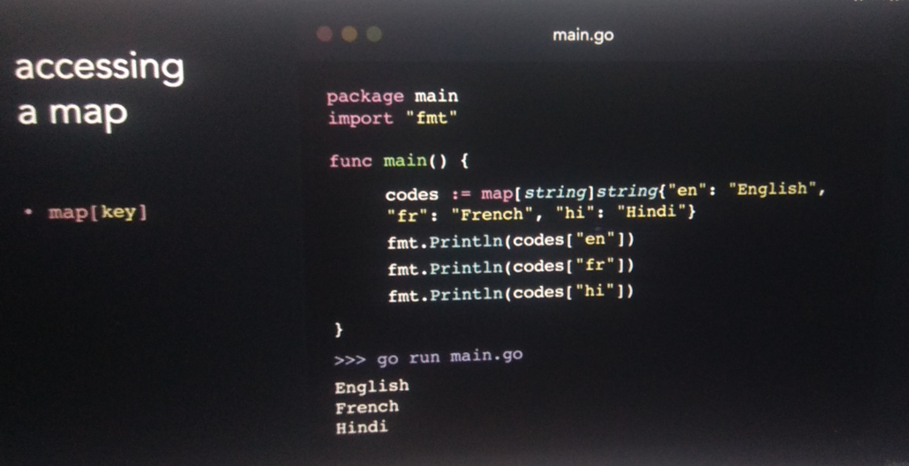

**Getting a key :**

Found is boolean value that indicates key exist

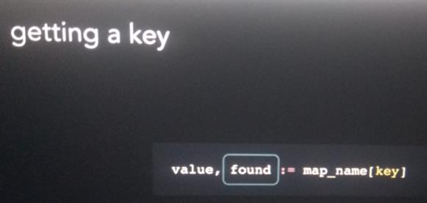

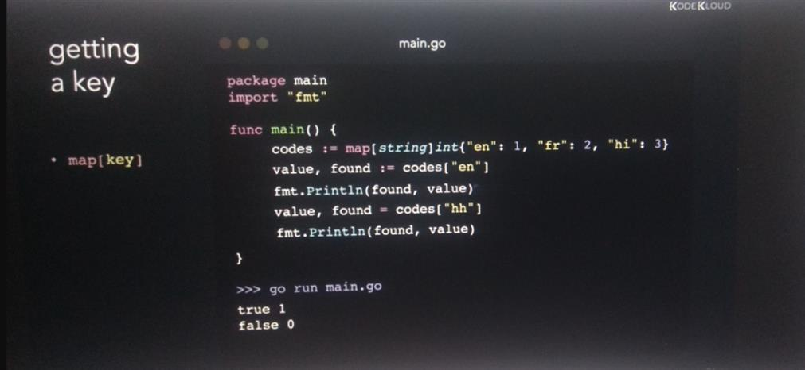

**Adding key value pair**

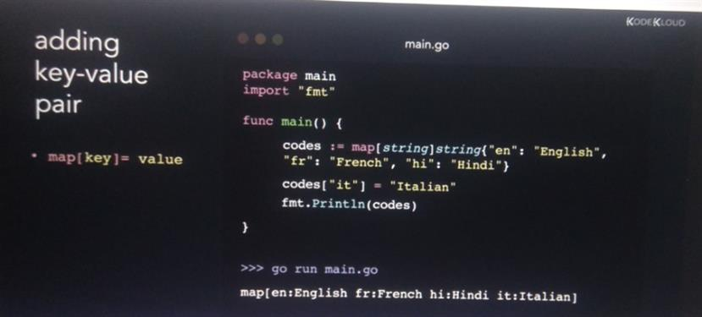

**Update key value pair : we can update by referring it key name**

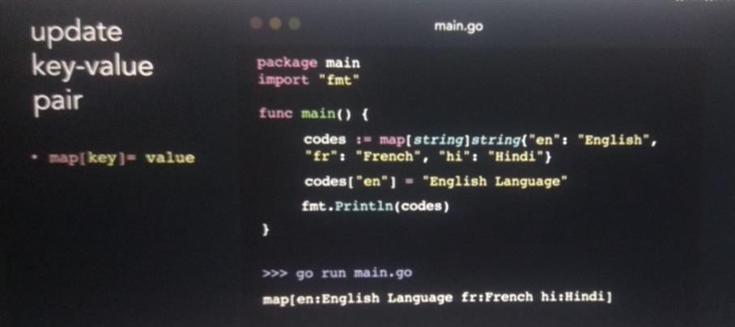

**Delete key value pair : it takes a map and key name**

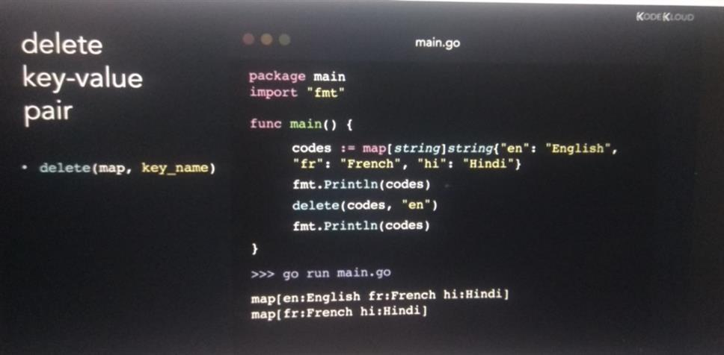

**Iterate over a map**

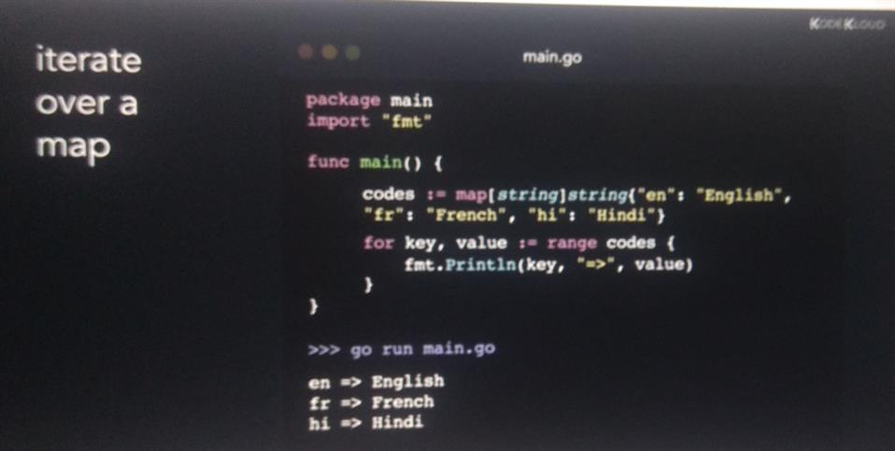

**Truncate a map**

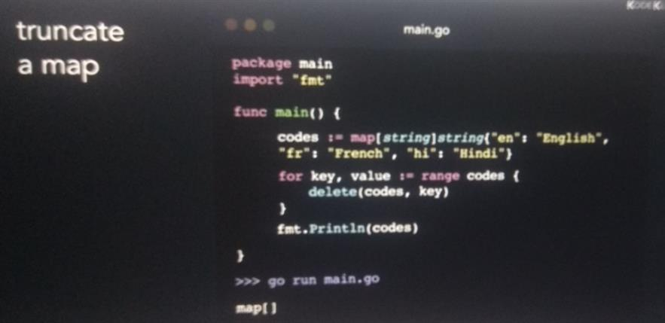

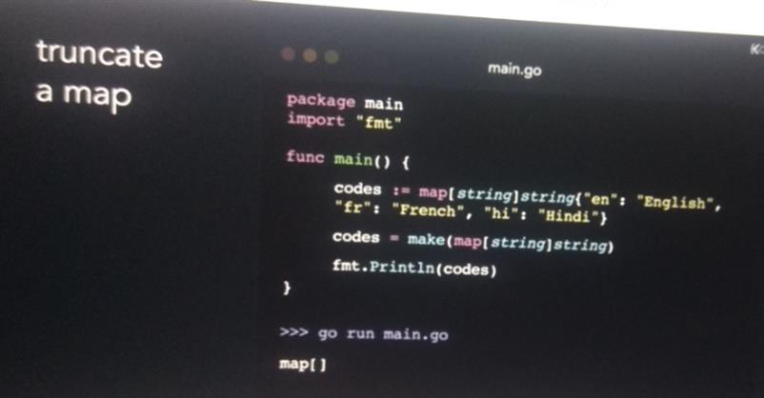

Section 5: Using functions

Introduction

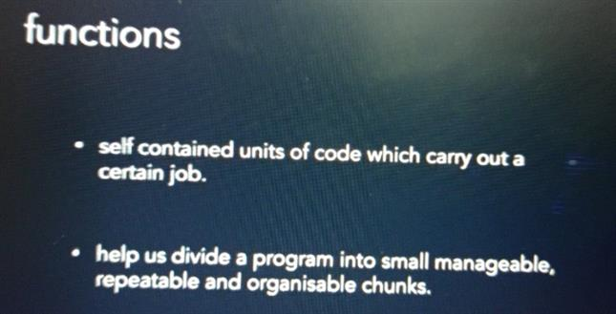

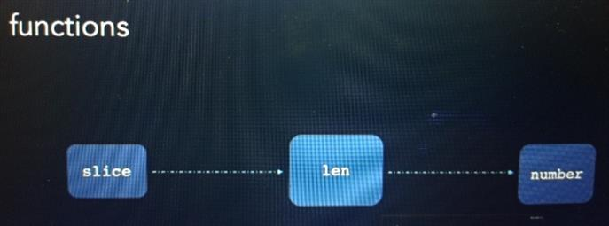

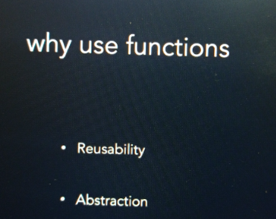

**Function syntax**

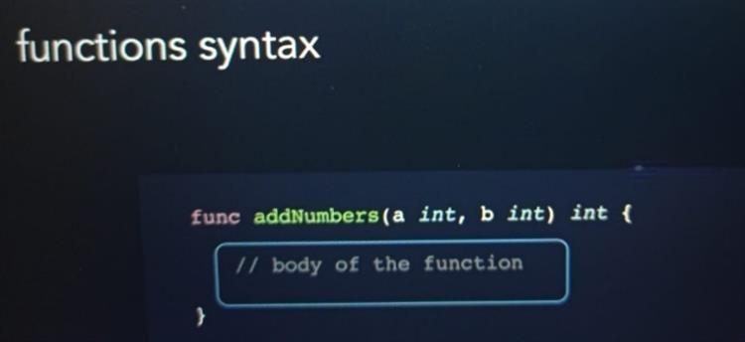

**Return keyword**

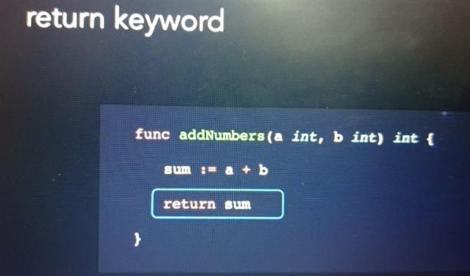

**Calling a function**

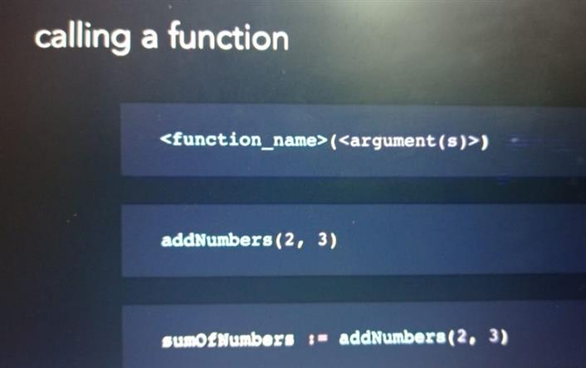

**Naming convention for function**

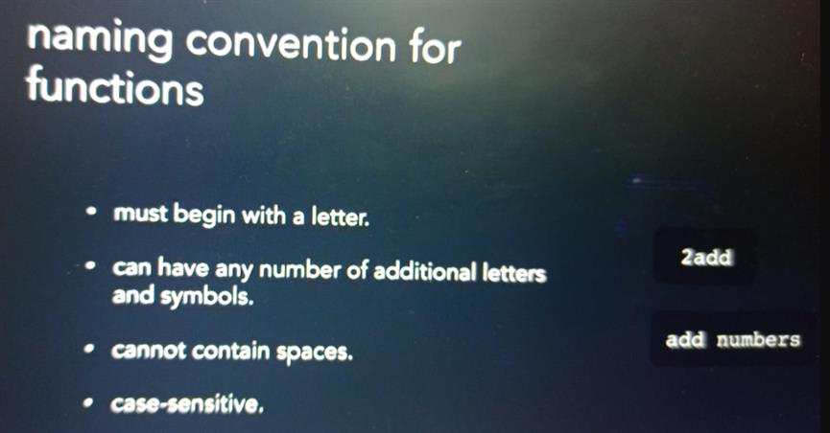

**Function vs arguments**

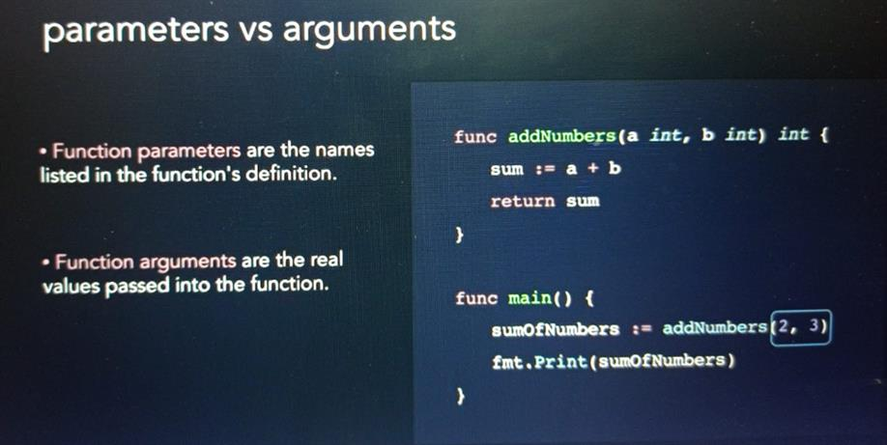

**Example**

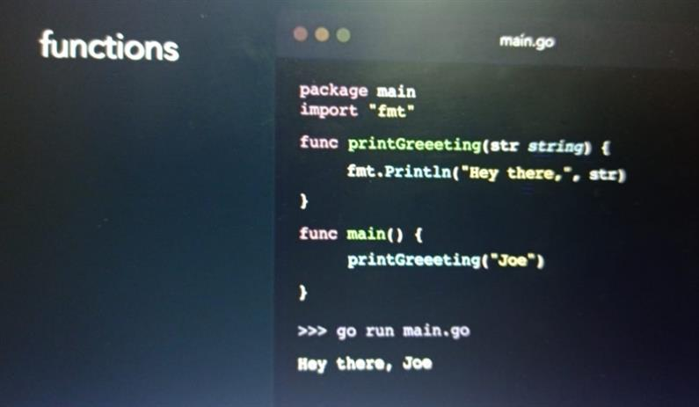

**Return types: multiple , named, vardiac**

**Multiple parameter return**

**Named return values**

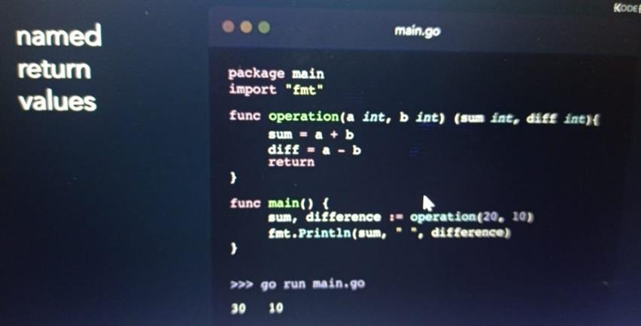

**Variadic functions**

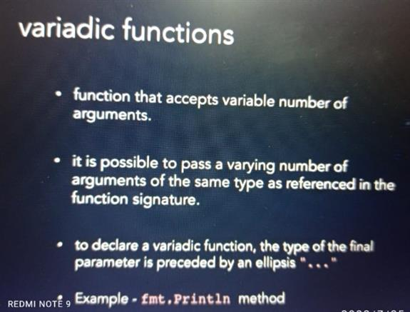

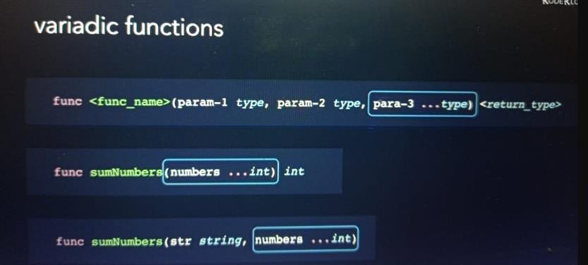

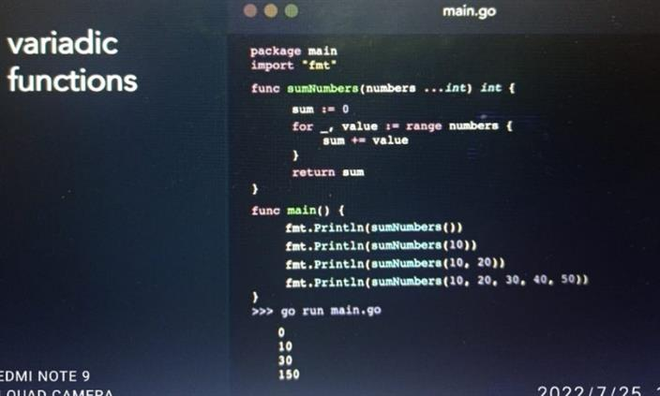

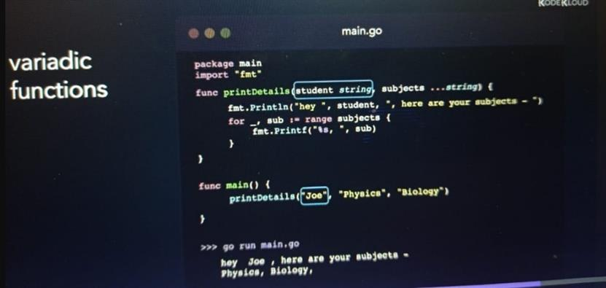

**Blank identifier**

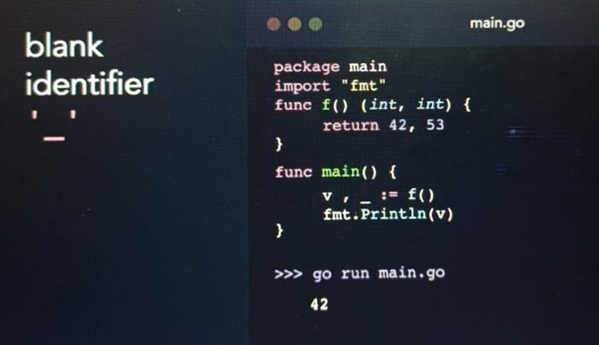

**Recursive function**

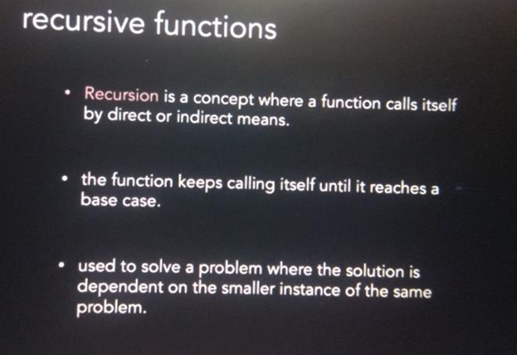

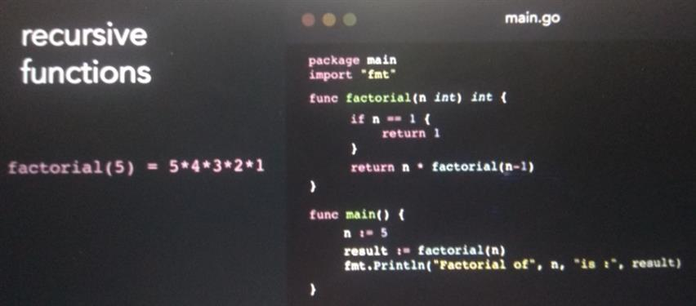

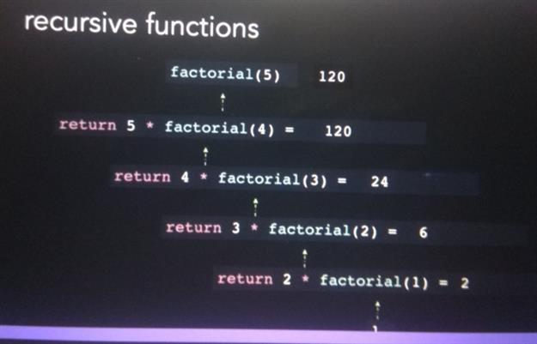

**Anonymous function**

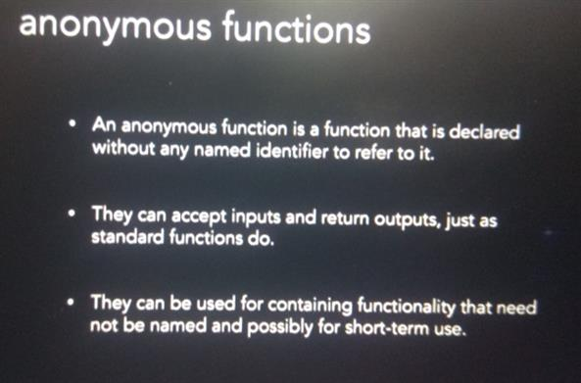

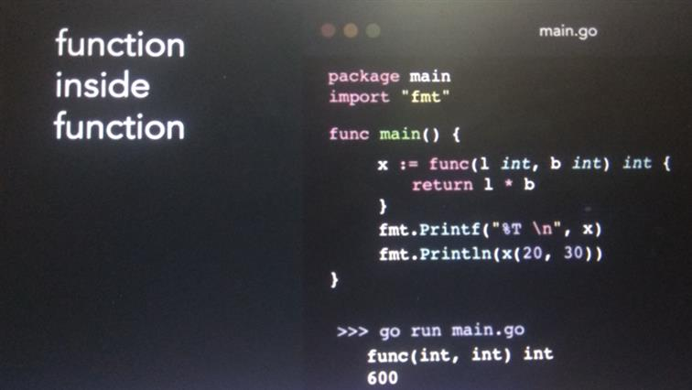

**X store the value return by the function so it data type is int**

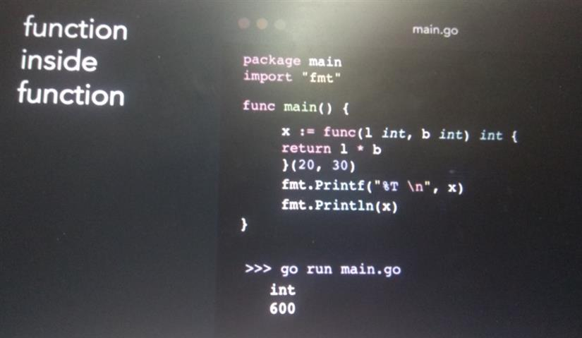

**Defer statement**

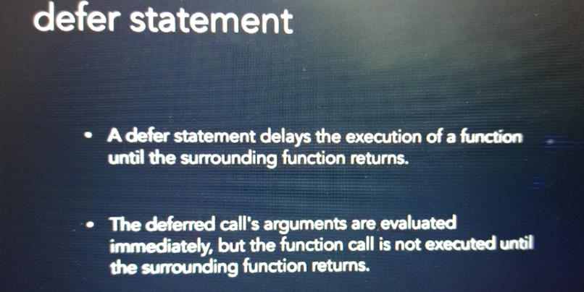

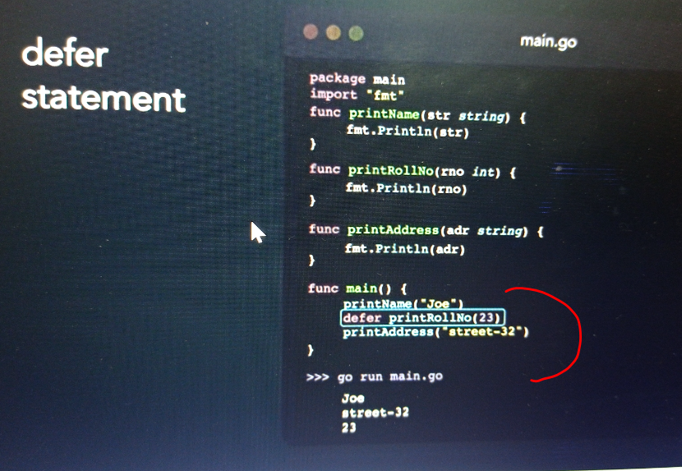

Section 6: Pointers

Whenever variable is declared a certain amount of memory is allocated in ram.

This memory allocation is done while the program is running and hence the variable may get different allocation while program is running

A pointer is a variable that hold the memory address of another variable

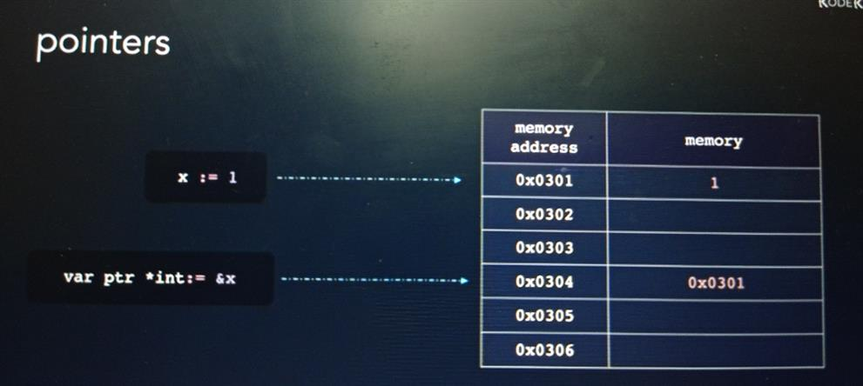

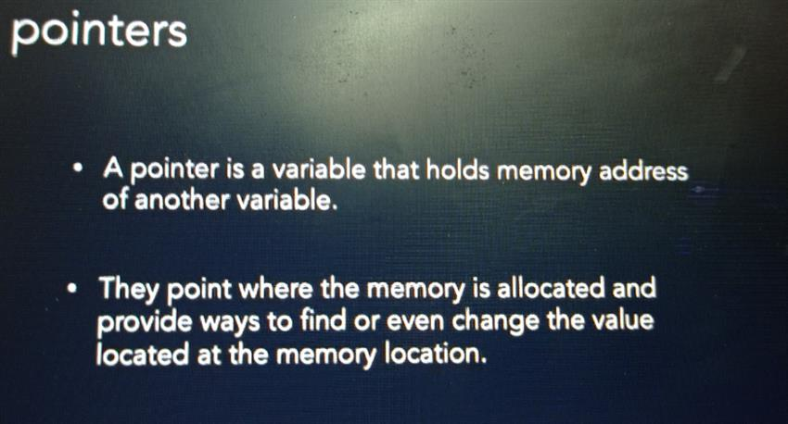

**Address and dereference operators**

**Address of variable &:** can be obtained by using &

Dereference operator * :- value at the address

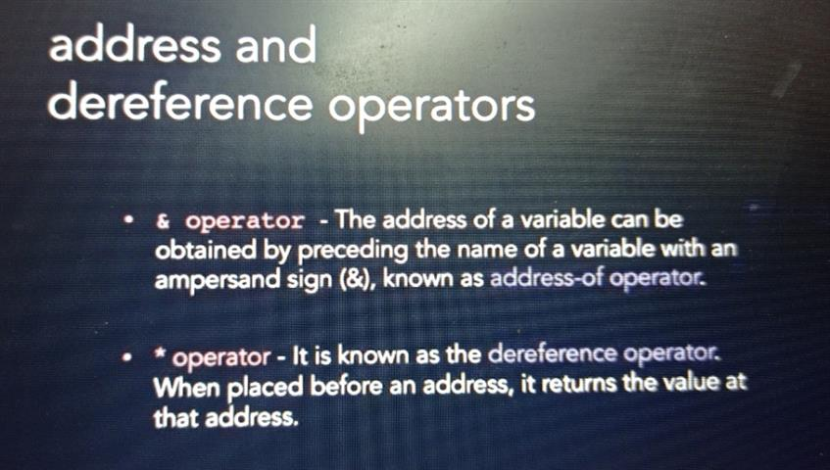

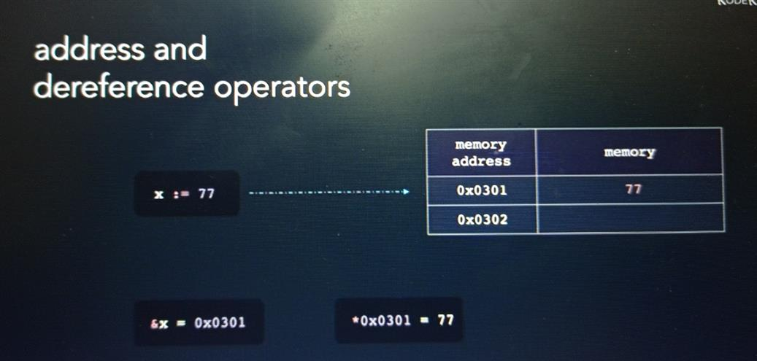

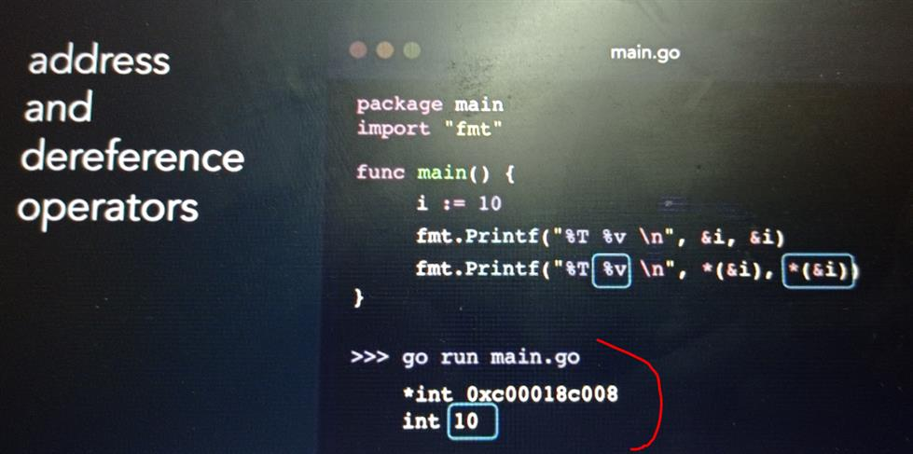

**Declaring and initializing a pointer**

**Declaring a pointer**

**Var <pointer_name> *<data_type>**

**Data_type :** of variable whose address we want to store

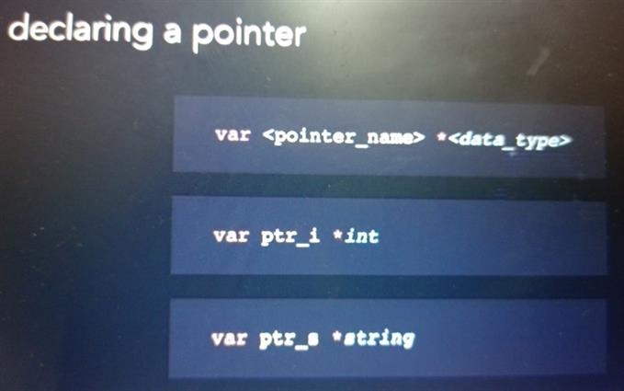

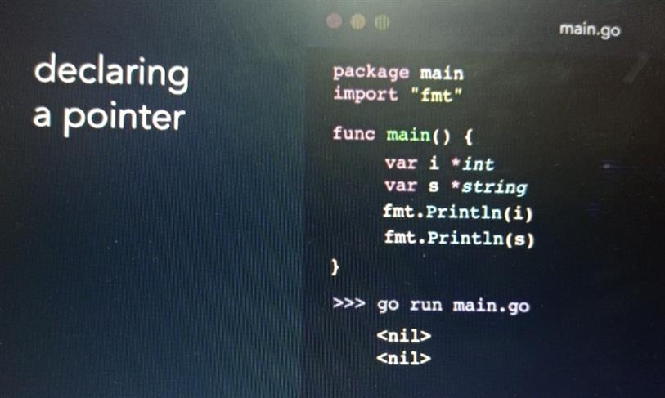

**Intializing a pointer**

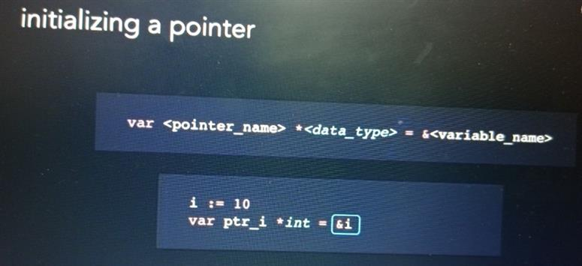

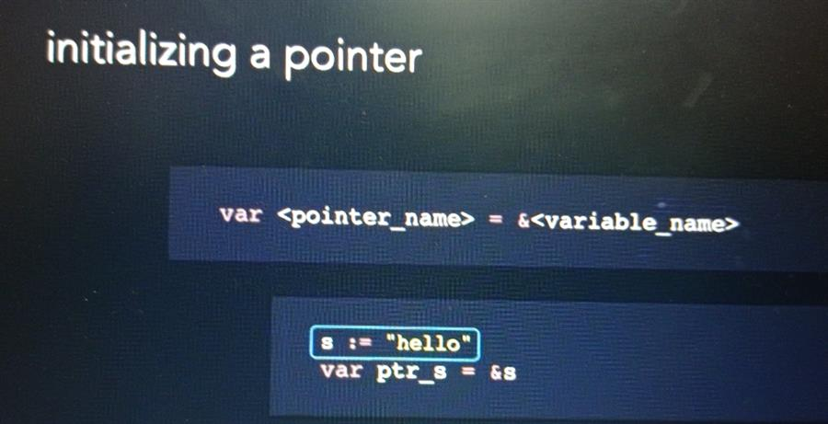

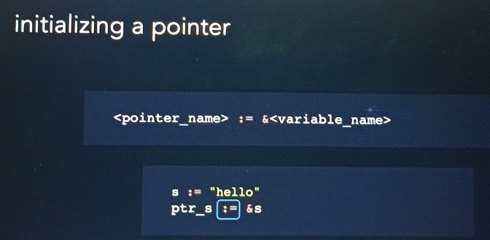

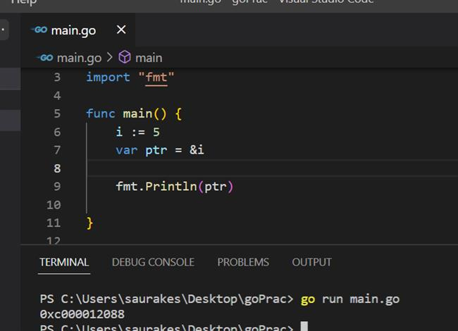

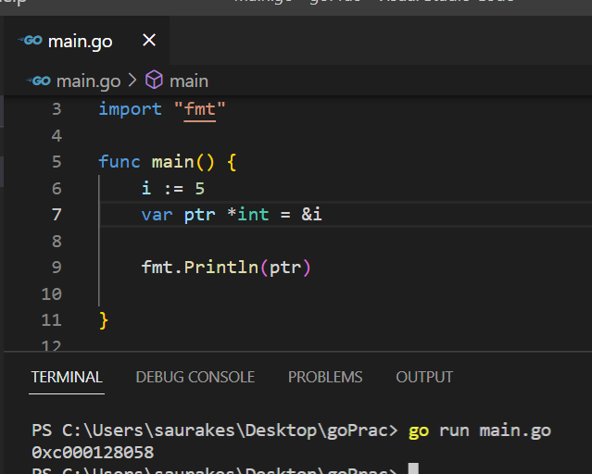

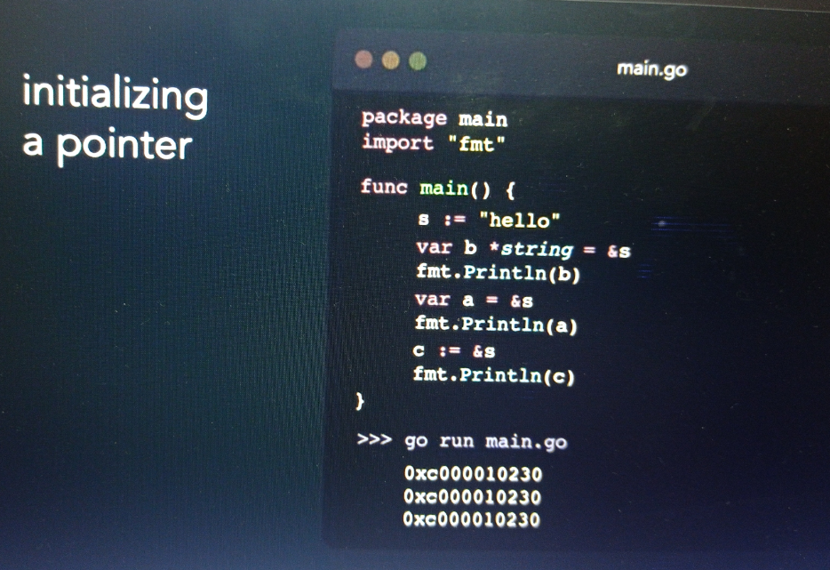

**Dereferencing a pointer**

**Note**

We can modify variable value using Dereferencing pointer

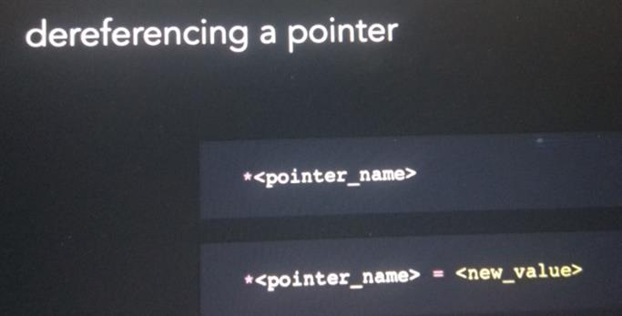

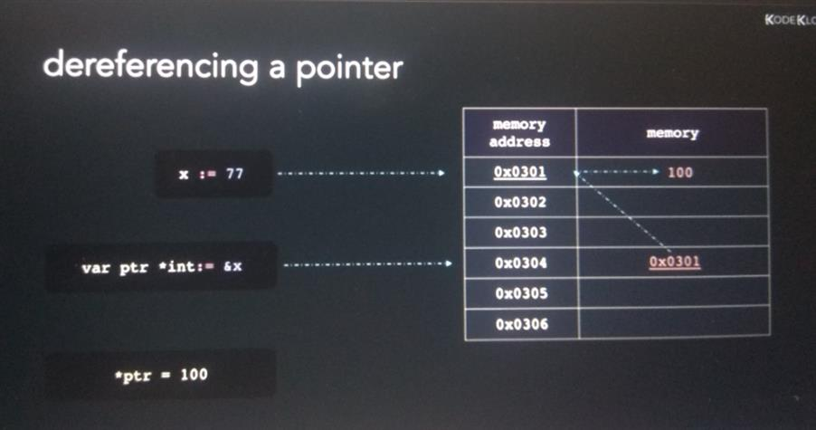

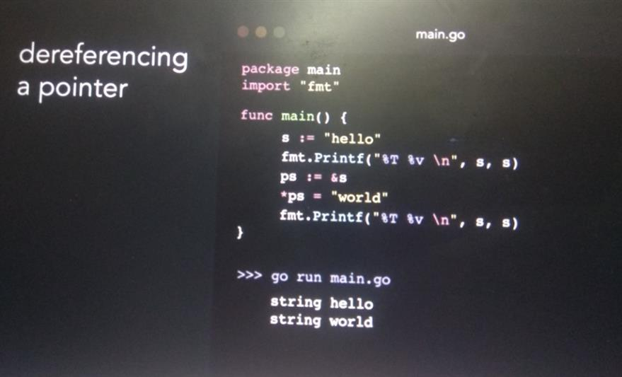

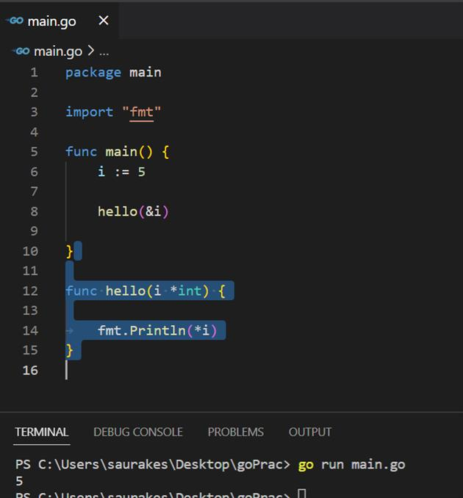

**Passing by value in functions**

**There are two ways passing value to a function**

Passing by value

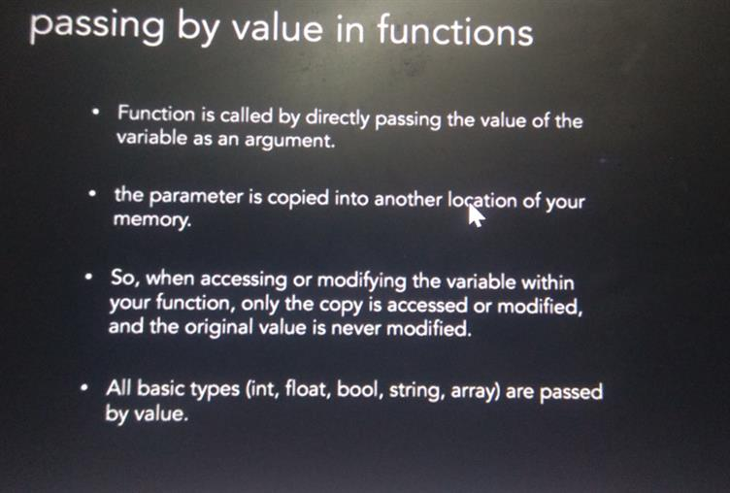

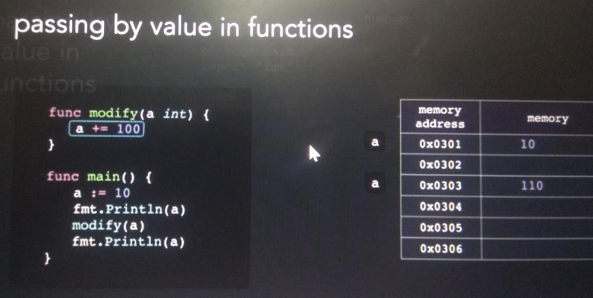

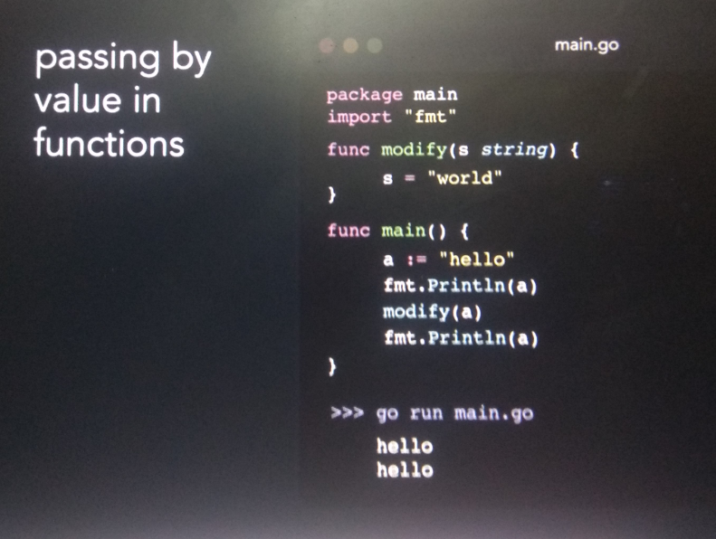

**Passing by reference in function**

**Pointer s is pointing to same location**

**Note :**

**Map and slice by default** passed by reference in method

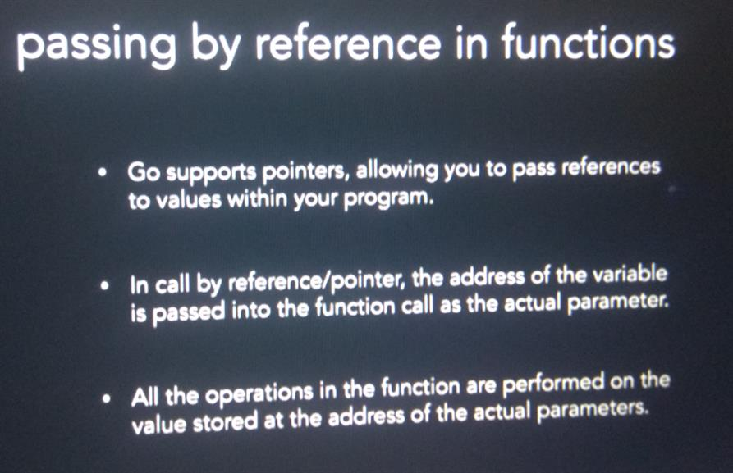

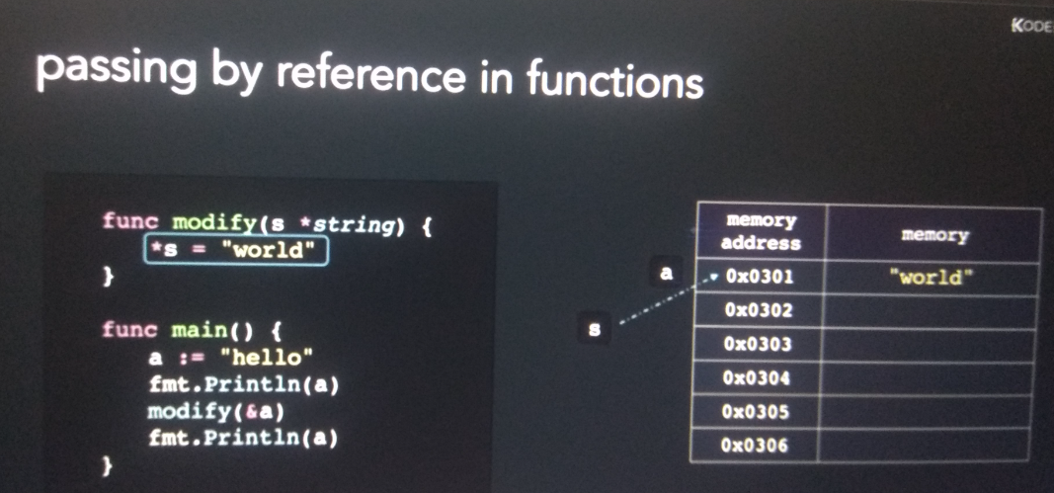

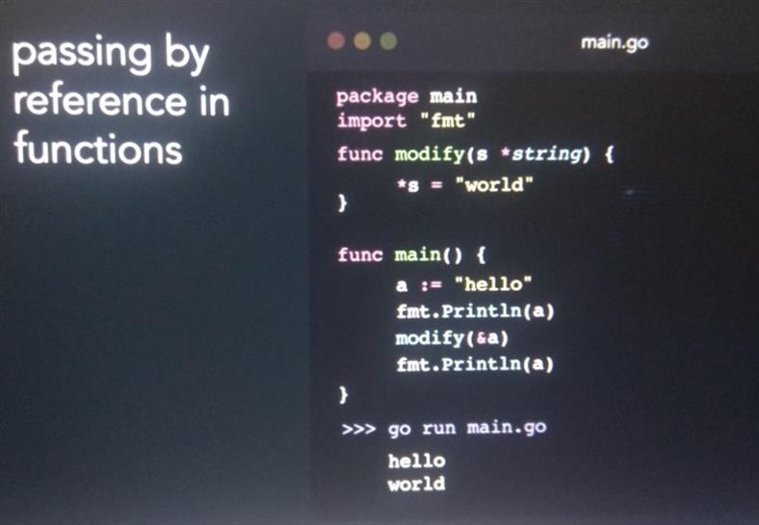

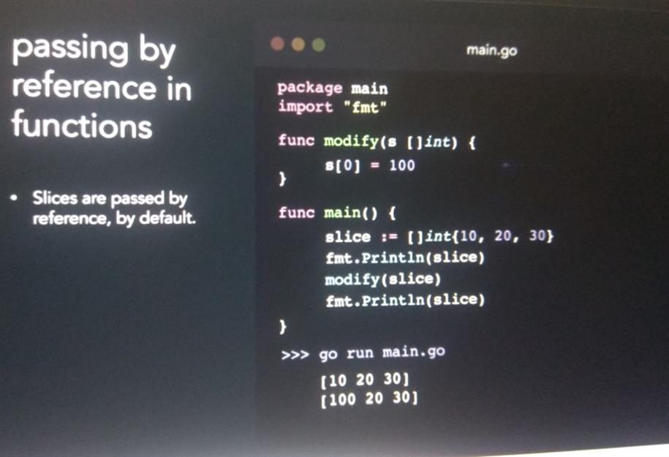

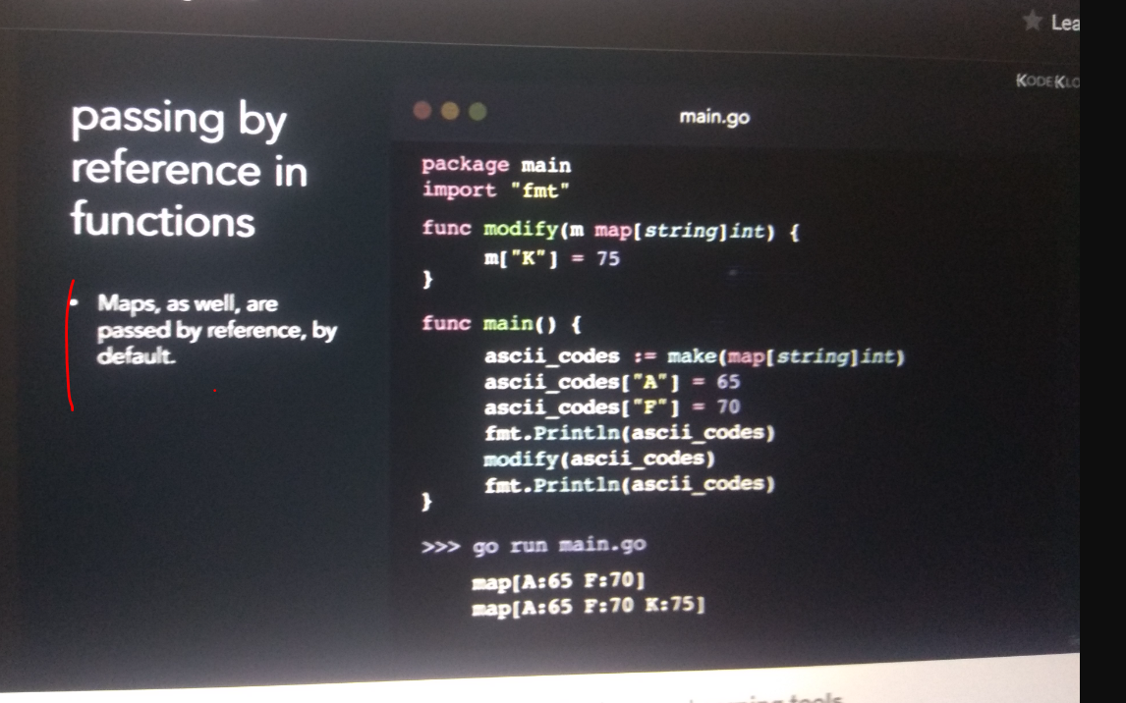

Section 7: Struct method and interfaces

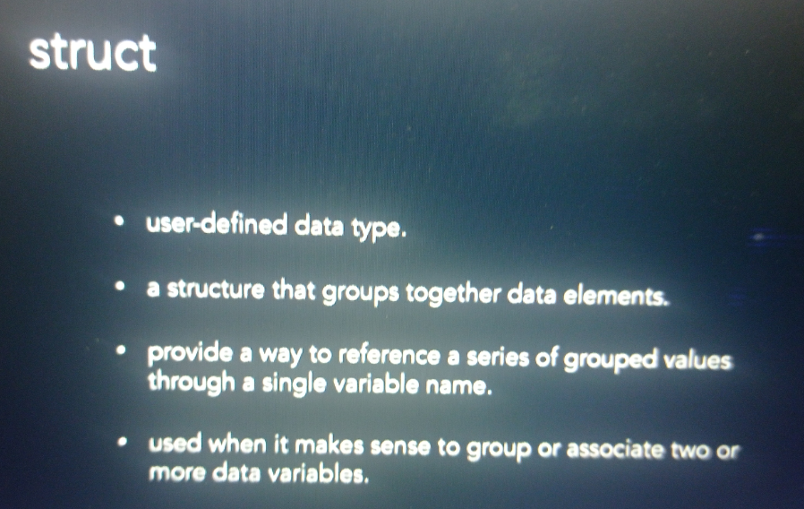

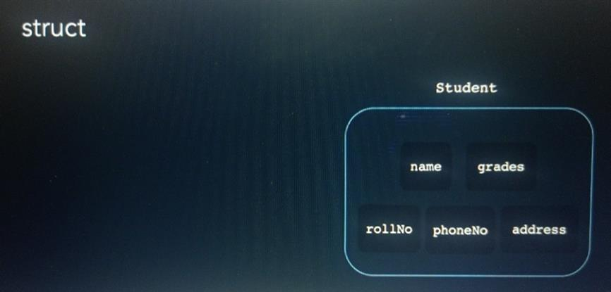

**Declaring and initializing a struct**

**Struct declaration**

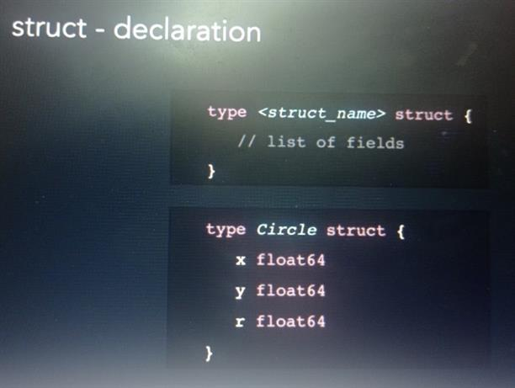

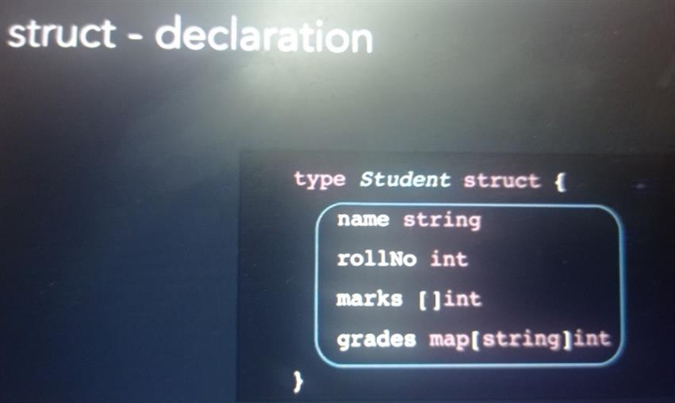

**Struct intialization**

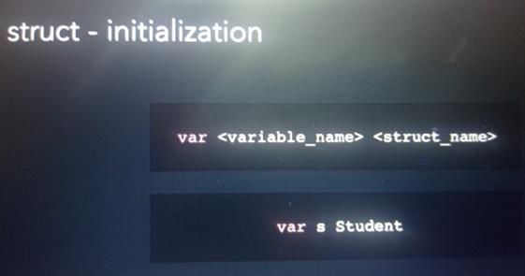

**Will initialize with default value**

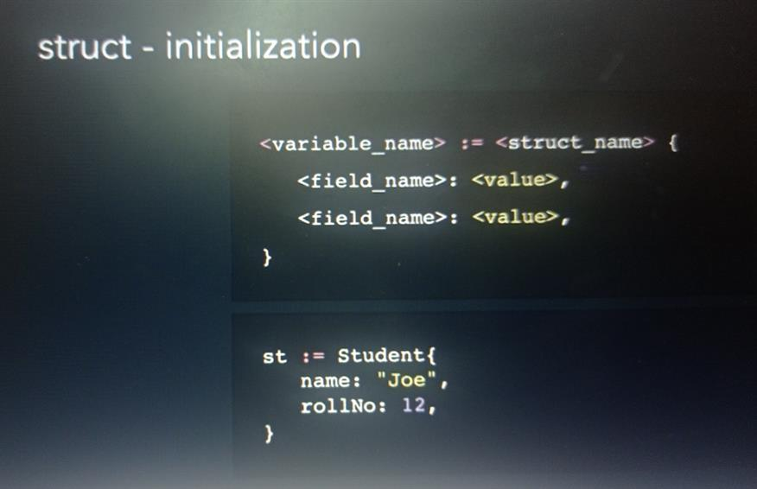

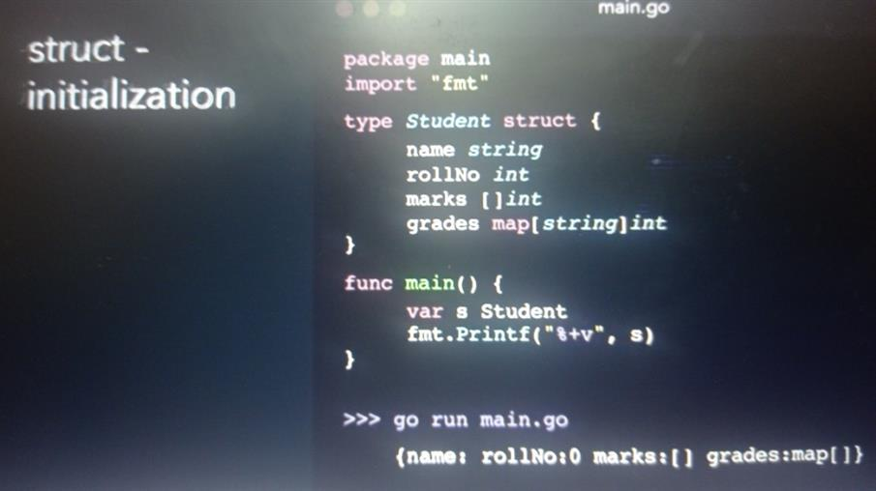

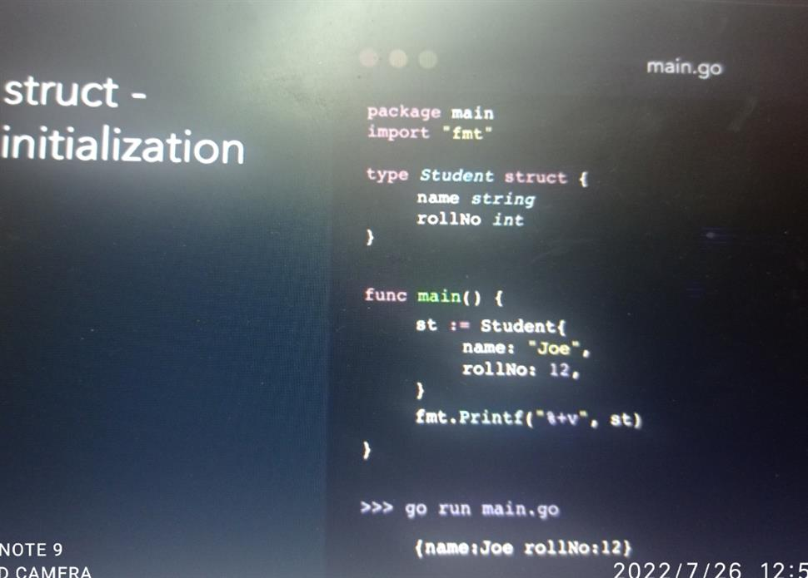

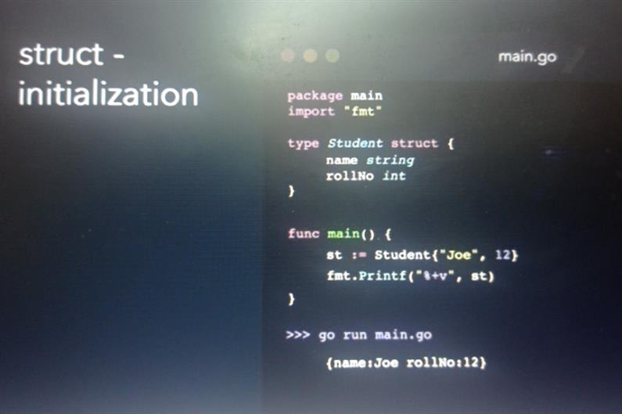

**Note :**

**New keyword will return a pointer**

**Accessing field**

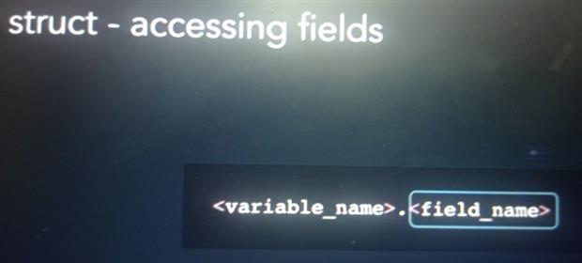

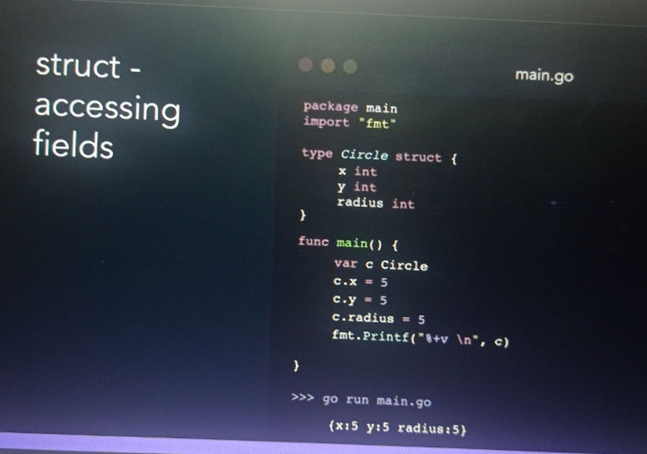

**Passing structs to function**

<https://www.digitalocean.com/community/conceptual_articles/understanding-pointers-in-go>

**Pass by value no change in struct**

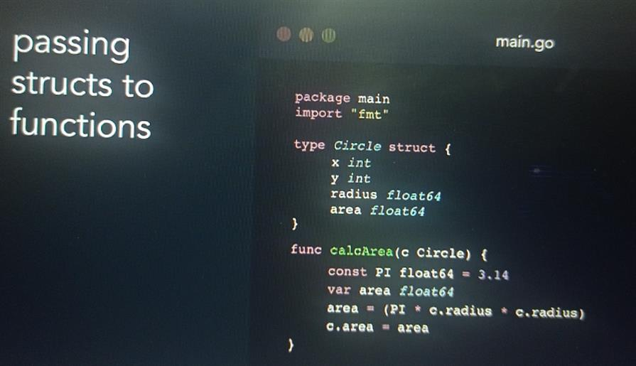

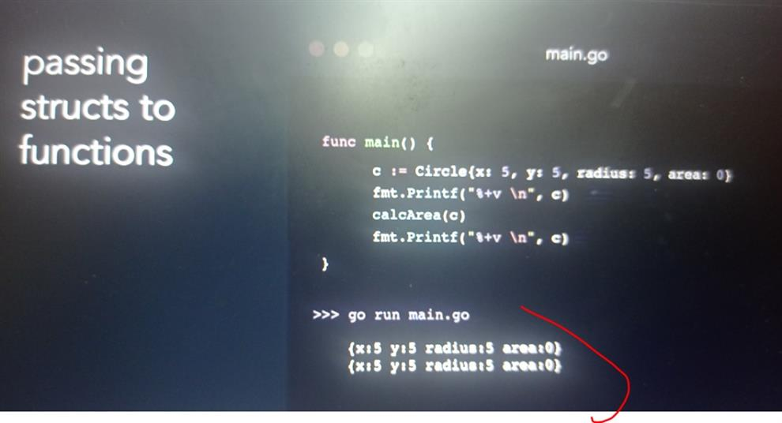

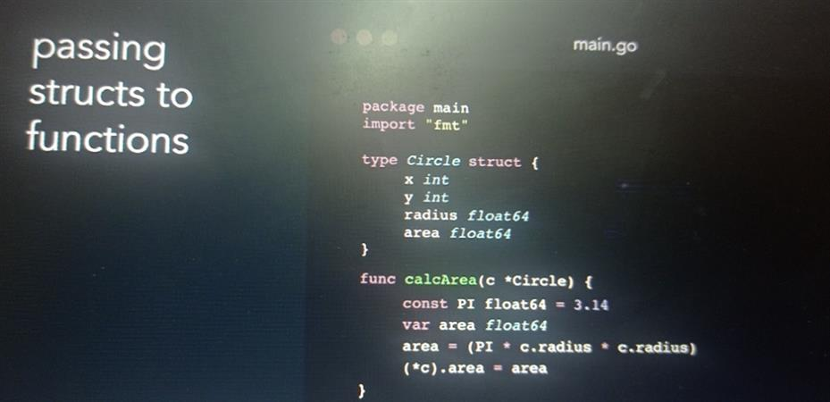

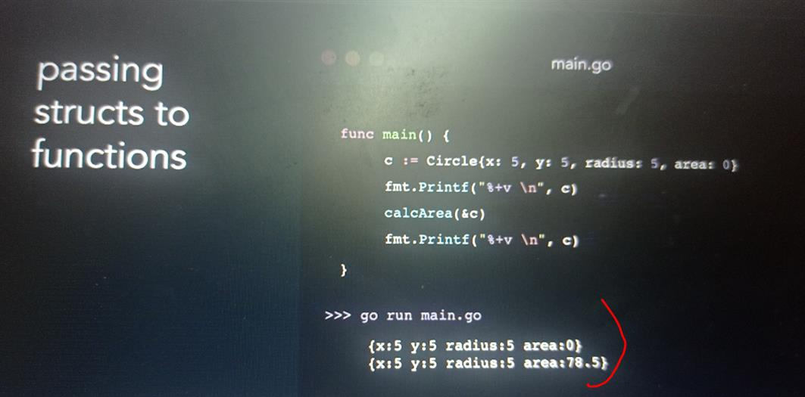

**Comparing struct**

**To check if struct is of same type and they have same value**

**Note :**

It is not possible to compare struct of different types

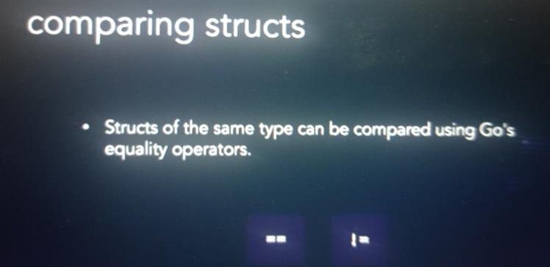

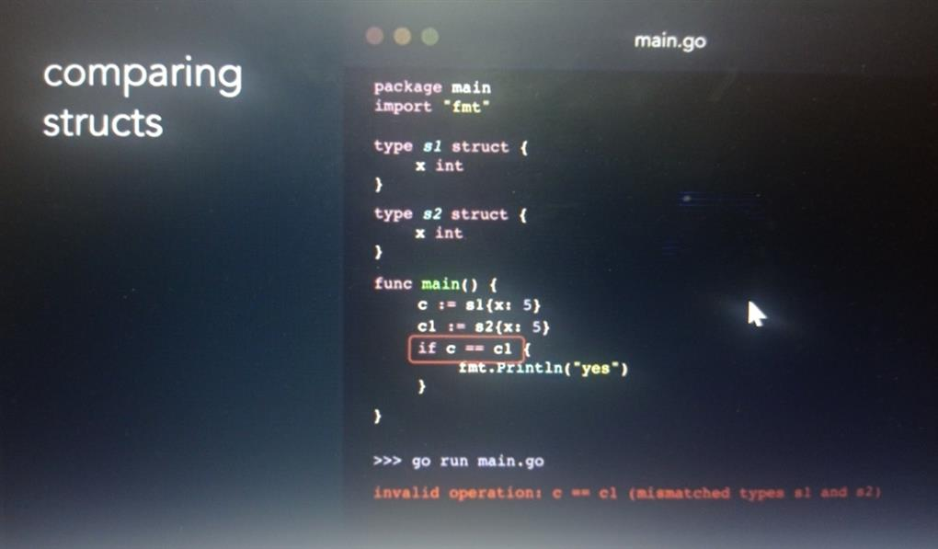

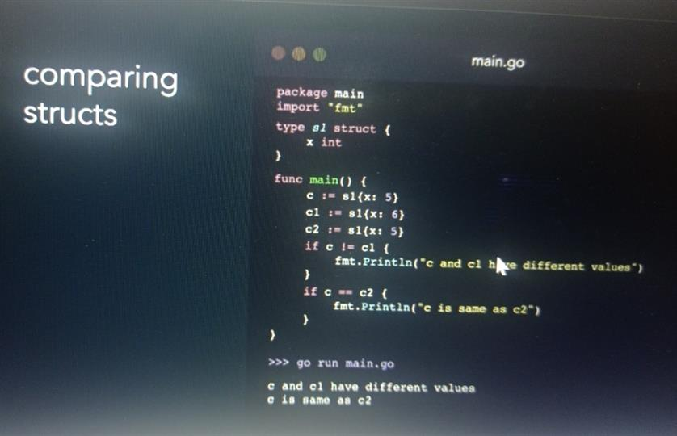

**Method : Introduction and syntax**

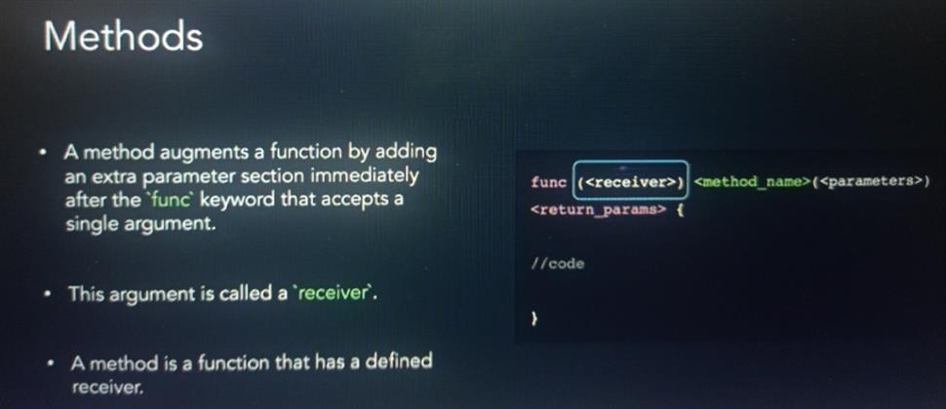

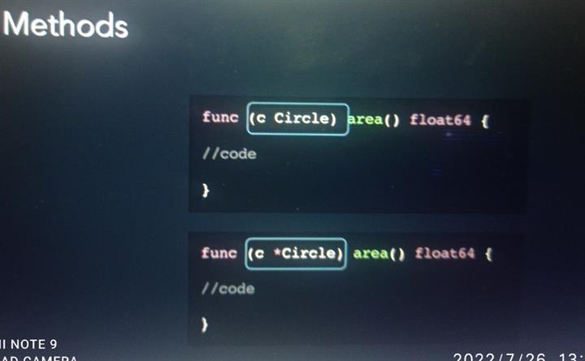

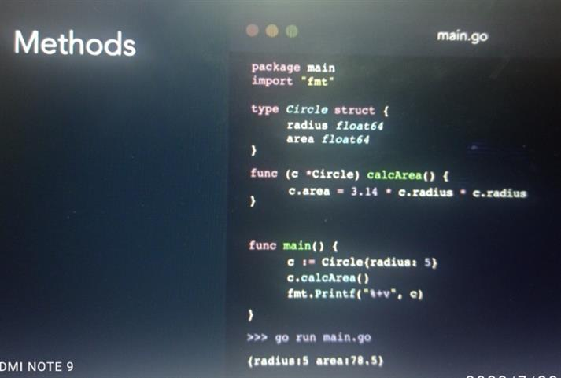

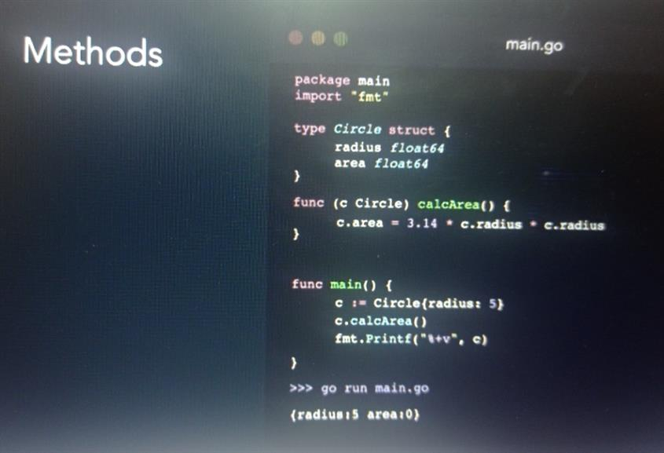

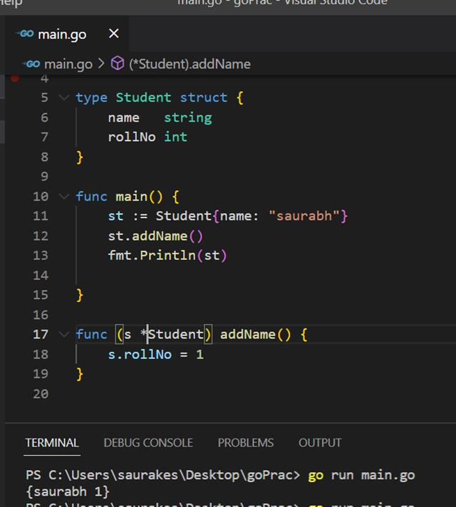

**Method sets**

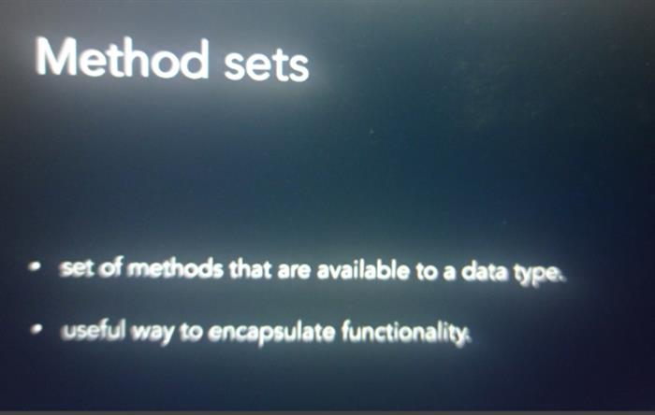

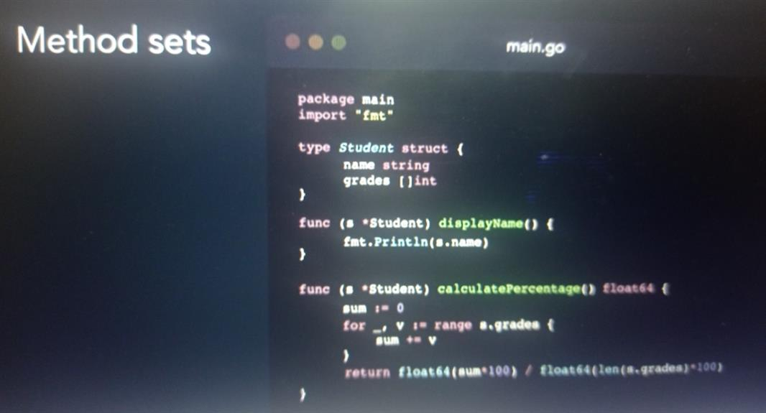

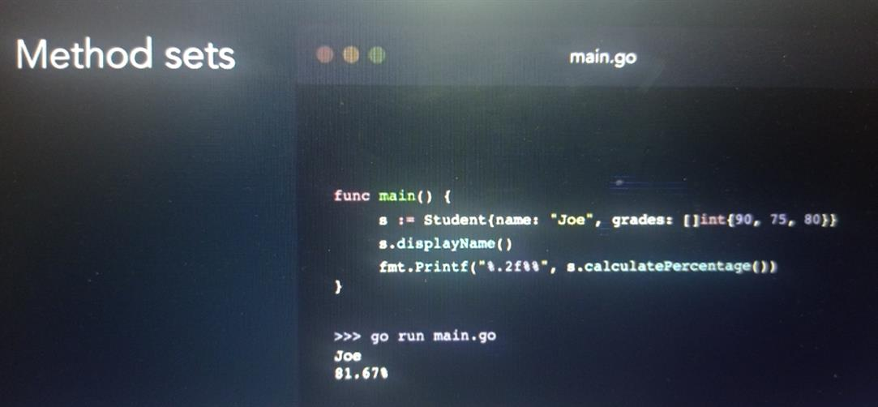

**Interfaces introduction and syntax**

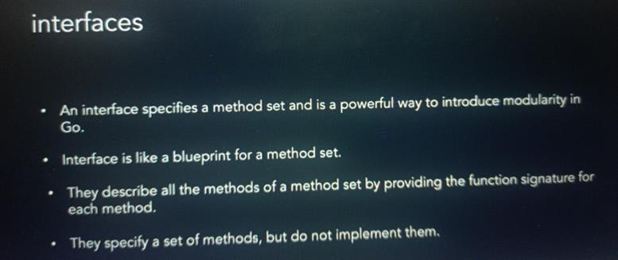

**Interface syntax**

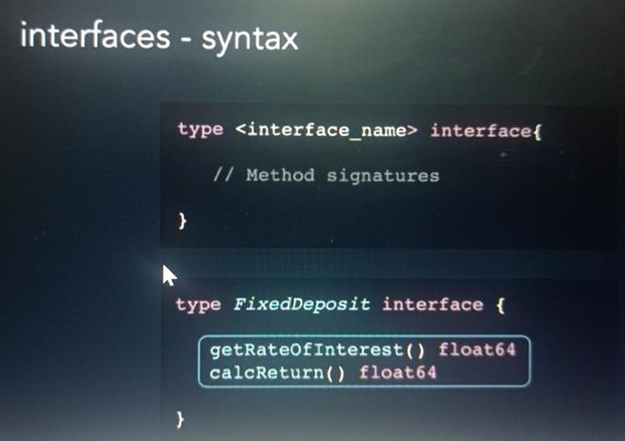

**Implementing an interface**

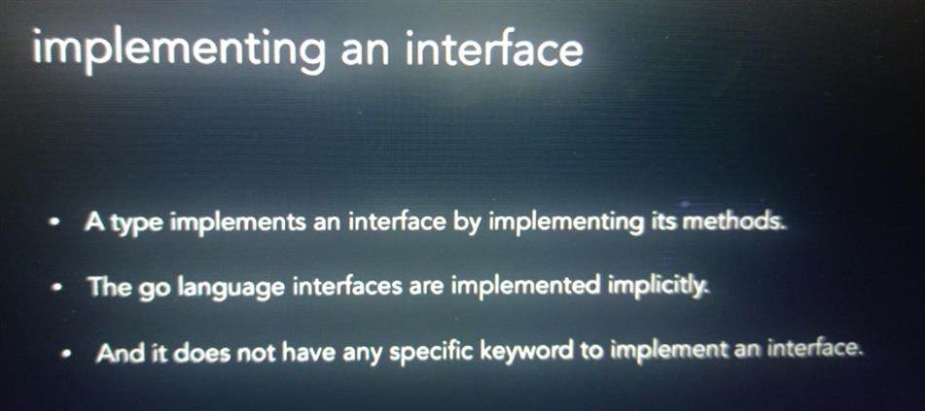

**Implementing interfaces**

**Define method in interface and any type using interface method have need to defined both method**

